

WOLLO UNIVERSITY
KOMBOLCHA INSTITUTE OF TECHNOLOGY(KIOT)
COLLEAGUE OF INFORMATICS
DEPARTMENT OF COMPUTER SCIENCE
Final Year Project on:- Web-Based Transport Management System for Kombolcha City Bus Station
PREPARED BY:

- Ahmed Hussen WOUR/ 0521/10
- Amare Degu WOUR/0527/10
- Gedefaye Melkie WOUR/0558/10
- Meseret Teferi WOUR/1448/09
- Seada Mohammed WOUR/1443/09

Advisor: Muluken M. (MSc.)
Kombolcha,Wollo,Ethiopia
July 24, 2021

Approval Sheet
This project is has been submitted for examination with our approval as the project advisor.
Advisor Name Mr___________ signature
This project is has been examined without approval as the project examiner.
1. Examiner Name signature
2.Examiner Name signature
3.Examiner Name signature

Acknowledgments
First and foremost, we would like to thanks our Almighty GOD for giving us all the capabilities to do things this project. Next to GOD, We wish to express our sincere gratitude to the Faculty Of Informatics, for providing us an opportunity to perform our project work on "Web-Based Transport Management system for Kombolcha Bus Station".We sincerely thank our project Advisor, Mr. Muluken M. for his diligence in advising and guiding us to through the right path, from the inception until the completion of this document. Finally, we have also a great pleasure for employees of Kombolcha City Bus Station especially Mr. Amanuel for spending their precious time with us and giving us the information we were searching for.

Table of Contents
Acknowledgments ii
List of Figures vi
List of Tables vii
Abstract viii
List of Acronyms and Abbreviations ix
Chapter One 1
1. Introduction 1
1.1 Background of the organization 1
1.2 Motivation 2
1.3 Statement of the problem 2
1.4 Objectives of the project 3
1.4.1 General Objective 3
1.4.2 Specific Objectives 3
1.5 Scope of the project 3
1.6 Limitations of the project 4
1.7 Significance of the project 4
1.8 Feasibility study 5
1.8.1 Economic feasibility 5
1.8.2 Operational feasibility 6
1.8.3 Technical Feasibility 6
1.8.4 Organizational feasibility 6
1.8.5 Tasks &Schedule Feasibility 6
1.9 Budget for the project 7
1.10 Methodology 8
1.10.1 Requirement gathering methods 8
1.10.2 Analysis and Design Methodology 8
1.10.3 Implementation Methodology 9
1.11 Communication plan 10
1.12 Team Structure 11
1.13 Organization of the project 11
Chapter Two 12
2. Description of the Existing System and Requirement Gathering 12
2.1 Introduction Existing System 12
2.2 Player in the existing system 12
2.2 Major functions/activities in the existing system like inputs, processes & outputs 14
2.4 Business Rule 14
2.5 Report generated in the existing system 15
2.6 Bottlenecks of the existing system 16
2.6.1 Performance (Response time) 16
2.6.2 Input (redundant/flexible) and Output (Inaccurate) 16
2.6.3 Security and Controls 16
2.6.4 Efficiency 16
2.7 Proposed System 16
2.8 Requirement Analysis Proposed System 17
2.8.1 Functional Requirement 18
2.8.2 Nonfunctional requirements 23
2.8.3 System Requirement 25
2.9 Modeling the existing systems 25
2.9.1 Essential Use Case Modeling 25
2.9.2 Essential User Interface Prototyping 26
2.9.3 Essential User Interface Prototyping flow diagrams 27
2.9.4 Domain modeling with class responsibility collaborator (CRC) 27
Chapter Three 30
3. System Analysis (Modeling the Proposed System) 30
3.1 Introduction 30
3.2. Modeling proposed systems 30
3.2.1 System use case diagrams 30
3.2.2 Use case Descriptions 32
2.2.3 Sequence Diagram 49
3.2.4 Activity Diagram 56
3.2.5 Analysis level class diagram (conceptual modeling) 66
3.2.6 User Interface Prototyping 68
Chapter Four 70
4. System Design 70
4.1 Introduction 70
4.2 Class type architecture 71
4.2.1 Architectural Design 72
4.3 Design Class Model 72
4.4 State chart modeling 76
4.5 Collaboration Modeling 78
4.6 Component Modeling 80
4.7 Deployment Diagram 80
4.8 Persistent Modeling 82
4.9 User Interface 82
Chapter Five 85
5. Coding, Implementation and Testing 85
5.1 Introduction 85
5.1.1 Coding 85
5.2 Final Testing of The system 88
5.3 Hardware software acquisitions 90
5.4 User manual preparation 91
5.5 Training 91
5.6 Installation Process 91
5.7 Start-up strategy 91
Chapter Six 92
6. Conclusions and Recommendations 92
6.1. Conclusion 92
6.2. Recommendation 92
References 93
Appendices 93

List of Figures
Figure 1.1 Grant chart of Schedule feasibility 7
Figure 2.1 Existing System Workflow diagram 13
Figure 2.2 Proposed system diagram 17
Figure 2.1 Essential use case diagram 26
Figure 2.2 Essential user interface prototyping flow diagram. 27
Figure 3.1 Use case diagram 32
Figure 3.2 Login sequence diagram 49
Figure 3.3 Create an Account sequence diagram 50
Figure 3.4 Update Account sequence diagram 51
Figure 3.5 Association Register sequence diagram 52
Figure 3.6 Logout sequence diagram 53
Figure 3.7 Upload Activity diagram 54
Figure 3.8 View Available bus Sequence diagram 55
Figure 3.9 Send Request Sequence diagram 56
Figure 3.10 Security login activity diagram 57
Figure 3.11 Activity diagram of creating account 58
Figure 3.12 Update account activity 59
Figure 3.13 Activity diagram of bus information registration 60
Figure 3.14 Passenger search for available bus 61
Figure 3.15 Prepare schedule activity diagram 62
Figure 3.16 Account deactivate activity diagram 63
Figure 3.17 Upload Available bus Activity diagram 64
Figure 3.18 Send Request Activity Diagram 65
Figure 3.19 Approve Request Activity diagram 66
Figure 3.20 Analysis level class diagram (conceptual modeling) 67
Figure 3.21 User Interface Prototyping 69
Figure 4.1 Class type architecture 71
Figure 4.2 Class diagram 75
Figure 4.3 State chart modeling for register association 76
Figure 4.4 State chart modeling for schedule request 77
Figure 4.5 State chart modeling for prepare schedule 78
Figure 4.6 Collaboration Modeling For Schedule Request 79
Figure 4.7 Collaboration modeling for prepare schedule 79
Figure 4.8 Component diagram 80
Figure 4.9 Deployment diagram 81
Figure 4.10 Persistent Diagram 82
Figure 4.11 Homepage user interface 83
Figure 4.12 Login User Interface 83
Figure 4.13 Association Registration user interface 84

List of Tables
Table 1.1 Budget Breakdown 7
Table 1.2 Communication plan 11
Table 1.3 Team structure 11
Table 2.1 Functional requirement description 19
Table 2.2 Nonfunctional requirement description 23
Table 2.1 Collaboration modeling for Admin 28
Table 2.2 Collaboration modeling for an Association manager 28
Table 2.3 Collaboration modeling for Employee 28
Table 2.4 Collaboration modeling for Dev’t process manager 29
Table 2.5 Collaboration modeling for Passenger 29
Table 2.6 Collaboration modeling for Operator 29
Table 3.1 Actor description 32
Table 3.2 Login use case description 33
Table 3.3 Use case description of account deactivate 34
Table 3.4 Use case description of Account Update 35
Table 3.5 Use case description of Account Create 36
Table 3.6 Use case description of Search 37
Table 3.7 Use case description of View report 37
Table 3.8 Use case description of Formed members 38
Table 3.9 Use case description of Request information 38
Table 3.10 Use case description of accept membership request 39
Table 3.11 Use case description of Approve request 40
Table 3.12 Use case description of register association 41
Table 3.13 Use case description of prepare schedule 41
Table 3.14 Use case description of update schedule 42
Table 3.15 Use case description of upload available bus 43
Table 3.16 Use case description of registered bus information 44
Table 3.17 Use case description of view registered association 45
Table 3.18 Use case description of generating a report 45
Table 3.19 Use case description of send request 46
Table 3.20 Use case description of the view 47
Table 3.21 Use case description of view available bus 47
Table 3.22 Use case description of view request 48
Table 3.23 Use case description of search bus information 48
Table 4.1 Class description 73
Table 5.1 Test case to register association 89
Table 5.2 Test case to view schedule 89
Table 5.3 Test case to update account 90

Abstract
This document is written to give detail information about Transport Management System of Kombolcha Bus Station. It is intended to describe the general operations of the bus station that are being performed daily. It is also aimed to describe the general approaches to be followed to automate the existing manual system to a computerized system. We are developing a web based transport management system for the bus station. It is done using the object oriented approach for development of the project. For the ease of understanding of the document, we have structured it into three chapters.
The first chapter is a general introduction and overview of the proposed system (proposal). The second chapter onwards, we have given detail descriptions for the existing and the newly proposed systems, about requirement elicitation processes that include the functional, non-functional and system requirements.
The third chapter is about use case diagram with description, sequence and activity diagram also include in this chapter.
The four chapter is about system design. It includes different diagram such as component, deployment, persistent and design class model diagram. The document is done by all the members of the group and we attached the interview and questioner questions used while data collection as appendix at the end.

List of Acronyms and Abbreviations
A: Alternative
Admin: Administrator
AminID: Administrator Identification number
BR: Business Rule
CRC: Class Responsibility collaborator
DB: Database
DEMID: Distributor Employee Manager Identification Number
Dev’t: Development
DOB: Date of birth
DPMID: Development Process Manager Identification Number
FREQ: Functional Requirements
Info: Information
KBS: Kombolcha Bus Station
KIOT:Kombolcha institute of technology
MYSQL: Standard query language
OPID: Operator Identification Number
PHP: A hypertext markup language
UC: Use Case
UML: Unified Modeling Language
WAMP: window Apache MySQL PHP

Chapter One

Introduction
Transportation is a process of moving people and objects from one place to another places. It has different types of transportation such as air transport through the air, water transport through lakes, rivers, seas or oceans, and land transport through the land spaces.

Background of the organization
The idea of modern land transportation in Ethiopia was first started during the time of Menilik II in which he brought a single vehicle from abroad. The idea was then developed by emperor Hailesilassie and grown into many services. From that time onwards people of Ethiopia tried to replace the transportation on the back of animals with modern means such as vehicles and the use of these vehicles became part of people's life.

Likewise, modern transportation from Kombolcha was also started during emperor Hailesilassie after 1955 E.C. Although there was transportation by that time, its amount was very less and there was no an organized bus station for later 17 years. Now there are more than twenty-seven (27) towns connected to Kombolcha Bus station.

This proposal is about the Kombolcha Bus Station transport management system. It is aimed to make the activities involved in the bus station computerized. The current system is being undergone manually and even if it can do its task well, its tasks are tedious and time-consuming since it is performed manually. Therefore, before going into detail about the project, let's discuss the background of the bus station. Kombolcha bus station (KBS) is located in the central part of Kombolcha city under Amhara, region of Ethiopia 374.2 km north of Addis Ababa. The Transport Supply and Cooperation Major Team are comprised of four major categories. The first category is the Transport Efficiency Qualifier who measures and checks the quality and efficiency of the transportation system provided to the society. The second category is the Transport Cooperator and Distributor (Simirit Yesira Hidet) who performs all the activities involved in the bus station. The third category is the Human Resource who manages and controls all the human resources that exist at the transportation system. The final category is the Road Transport Security Authority that manages all the security issues that occurred during transportation. Therefore, Kombolcha bus Station is under the Transport Cooperator and Distributor category of the Transport Supply and Cooperation Major.

Motivation
The main reason that initiates us to start thinking about developing this type of project is because the manual operation of the current system results in tedious routine tasks and time-consuming activities despite the inefficient overall system. Thus, we as a team proposed this web-based system which is far better than the current manual system in performance as well as cost if it is well designed and implemented or developed properly.

Statement of the problem
In fact, Kombolcha bus station is doing its intended tasks and has been working for its goals based on the current human-intensive manual system it has been characterized by several problems as mentioned below:
- They are assigning turns and destination places manually. This process is a great task that requires much time and effort to accomplish. Turns and places are being assigned once a month and they are expected to assign for all destination areas. Therefore, doing this task manually is time-consuming and tedious. In addition to this, doing this task manually is also prone to errors and biases.
- They are recording information about buses and Associations (Mahiberat) manually in paper documents. Recording information using paper documents is not reliable since it may be lost or harmed by certain damages. In addition to this, it is hard and time taking to search and get specific information from a huge paper document.
- There is no means for passengers to get updated information about the available buses allocated for different lines, the starting time and place, the destination, and related information rather than appearing physically.
- The manual system does not allow Associations (Mahiberat) to view all the available working areas and from Kombolcha and make a selection based on their requirements.

Objectives of the project

General Objective
The general objective of this project is to develop a Web-based transport management system for Kombolcha Bus Station.

Specific Objectives
To achieve the general objective, the following specific objectives are identified:
- To Record, all data related to buses and Associations (Mahiberat)
- To conduct a Literature review suitable to introduce a better system
- To study and analyze the limitations of the existing system.
- To design transport management system for Kombolcha bus Station
- To develop, and implement a transport management system for Kombolcha bus Station
- To evaluate and report the system

Scope of the project
The project is going to be done including the following areas of tasks involved in the bus station transport coordinator and distributor team (Simirit yesira hidet). These are:
- Data registration of vehicles and manipulation of these data
- Data registration of associations and manipulation of these data
- Adjusting turns/schedules for the vehicles that are serving society under KBS.
- Checking maintenance records to assess the quality and performance of vehicles.
- Recorded bus order based on their arrival time
- Assign the workplace timetable(Merhagbr) for each bus
- Update and delete some recorded data’s
- Register new bus to the bus station and assign workplace based on owner need and association permission.
- Passengers can view available bus with their level
- System interface implemented with both Amharic and English language
Activities are not considered as part of this project:-
- It does not do actions that are performed outside of the Transport Cooperator and Distributor team (Simirit Yesira Hidet).
- It does not do booking or reserving of tickets for passengers.
- Cannot formulate and establish tariffs

Limitations of the project
The limitation is activities of the system will not perform. There are some limitations within the proposed system those are listed below.
- Cars that provide cargo service are no entertained.
- The system will not allow the station to communicate with other bus stations.

Significance of the project
This project is significant for different stakeholders in different aspects. Among these:
- For Kombolcha bus Station workers: currently, the workers of the bus station are performing their tasks manually. This way is tedious and time taking and they are unable to do their tasks without required to spend much effort. Therefore, this project allows them to perform their activities easily.
- For the passengers: in the current system, passengers need to appear in person to get the information they want from the bus. This project allows them to get the information they want which is accessible from anyplace anywhere where internet access is available.
- For Associations (Mahiberat): these Associations are expected to go to the Transport Cooperator and Distributor team (Simirit Yesira Hidet) and submit their information and needs using a paper format which does not allow them to see which areas are better for work and not crowded. However, this project is proposed to allow them to view this information through DBMS techniques.
- For Government officials: in the current system, if someone requests to get specific information, he/she has to stay and wait until it is found from a huge document. However, using this project, one can get what he/she wants within the duration of time since it is equipped with searching techniques.
- For Group Members of the project: members of this project (students) have to get and also get much knowledge and experience of system development and problem-solving. Besides this, we as a team are encouraged to solve any other real-world problems that we will face in our real-time lives.

Feasibility study
The main objective of the feasibility study is to test the Technical, Operational, and Economical feasibility of adding a new system and debugging an old running system.

Economic feasibility
The purpose of assessing economic feasibility is to identify the financial benefit and cost associated with the proposed system, economic feasibility is referred to as cost-benefit analysis. We are going to determine the economic feasibility of this project by dividing it into two. Those are tangible and intangible benefits.
I) Tangible Benefits: -Benefits that are easily quantified from the conducted system are:
- Save time and make comfortable access for the users.
- Reduce cost for manual data management (Reduced expenses).
- Reduce Resource Consumption.
II) Intangible Benefits: -Benefits from the system those areas unquantifiable are
- Better decision making
- Enable efficient registration service for all users.
- Increase security
- Increase Management flexibility
- Knowledge gain by the project developer.
- Increasing the competitiveness of the individual
- More timely, updated, and accurate information
- Improved productivity
- Improving the morale of our team.
- Facilitating information processing of our team

Operational feasibility
The system which we developed is operationally feasible. It works well with all the solutions in the Transport Management System. This system is a web-based system for Transport Management System in Kombolcha City. So it attains its desired objectives. It will solve the problems in passenger find bus; therefore it will minimize the amount of effort to do all through manually. And it performs the basic functionalities that are planned to use.

Technical Feasibility
The system which we developed will be technically feasible. The system is technically feasible since the teams developed it easily by using simple programming languages and software like Html, JavaScript, MySQL, and PHP. These languages are simple, open-source, and already known, so the team developed the system easily. We expect that the system can be operated in a simple way and all users can access it easily by giving simple training for them. It doesn't require any technical expertise and can be integrated with the existing system.

Organizational feasibility
The system can be organizationally feasible because the system we will develop is based on the policies of the company and it will be developed according to the interest of the company and also the project magnifies the qualification of the company.

1.8.5 Tasks &Schedule Feasibility
This project is expected to be completed in two semesters of the 2013 academic year. Some parts of the project component to be completed in the first semester are up to design and the rest of the activities such as design, implementation, testing, and maintenance would complete in the next semester including other minor activities. We will produce the project proposal and other activities of the project development based on the schedule shown below.
Figure 1.1 Grant chart of Schedule feasibility

Budget for the project
The amount of money needed for this project is listed below:-
Table 1.1 Budget Breakdown
Tools | Item | Quantity | Estimated Unit cost in birr | Estimated Total Cost in Birr
Hardware Tools | Paper | 1 packet | 120 | 120
 | Pen | 10 | 5 | 50
 | Mobile card | 20 | 10 | 200
 | Flash | 2 | 150 | 300
 | Computer | 1 | 20,000 | 20,000
Software Tools | MS word | Free | 0 | 0
 | E-draw max, Visual Paradigm, and Microsoft Visio. | Free | 0 | 0
 | Apache | Free | 0 | 0
 | MYSQL | Free | 0 | 0
 | Total cost |  |  | 20,670

Methodology

Requirement gathering methods
We have undergone different types of data collection mechanisms to get the necessary information about the project and to understand the nature and working conditions of the existing system. These are:
- Interview
To determine the objective and scope of the system by interviewing related offices to gather information about the manual system of bus station management system what looks like. We contact the representative of the organization and then exchange some ideas about their current system, how it has been working, and the structure of this organization. As a general, we gather enough data to prepare our project. The team uses interviews to collect information from record offices and managers.
- Observation
In addition to the interview method, we have deeply observed the functionalities of the bus station in its natural setting without being known by the workers. Through it also we have got many ideas. We gather the information related to the record office through observing while they checklist of the bus station, this helps us to have input or information to design the system.
- Questionnaires
To get more information we select some workers and prepare questions about the system. The questionnaire is both closed and opened ended questions. To prepare the questioner for only some peoples by selecting education level. We used stratified sampling.

Analysis and Design Methodology
Object-Oriented Approach: the method of system development paradigm we selected is the object-oriented approach because this approach is helpful for us to represent the different phases of the project through many diagrammatic representations such as activity diagrams, use cases, sequence diagrams, class diagrams, etc. Generally, we choose object-oriented development design because of:-
- These techniques have a reusability feature.
- These techniques provide greater opportunities for users to participate in the development process.
- This increases flexibility.
- This also improved quality.
- These techniques are the latest, powerful, easy, and highly usable.
- Increase domain and design reuse.

Development Approach
In our team, we select the iterative model approach because to design our project we are required to review and redesign in each phase iteratively to meet user requirements.
- To learn from earlier development versions.
- The iterative model is the simplest model of software development tools.
- All the phases of SDLC function one after another cyclic manner.
- To get quick end-user feedback &make an enhanced system.
- Easily identify missing functionalities.

Implementation Methodology
We use the following programming tools to develop our system.
- Edraw Max UML 8.0 tool: - used to draw different UML that is necessary to design analysis system and database design.
- Visual Paradigm 14.0 is used to draw a persistent diagram.
Back end tools
- MYSQL server
We select MYSQL DBMS because
- MySQL database is fast
- MySQL database is free to use
- MySQL database is compatible with the PHP platform.
Front end tools
- HTML
We select HTML because:
- Html is a platform-independent language that is predominantly used in web and web-based applications.
- PHP
We select PHP because:
- Php can work on a variety of platforms including Windows and UNIX. The base part is that PHP is efficient with the popular server, which is Apache.
- JAVASCRIPT
We select JavaScript because:
- JavaScript is browser-independent
- It allows the creation of an interactive web page
- Source code editors
- Notepad++
- Webserver: Apache 4.1.14
- Web browser: Mozilla Firefox 59.0 or any compatible browser.

1.11 Communication plan
While we were worked on our project, we have used the following techniques in order to meet one another and then exchange our suggestions or ideas. Those techniques are listed in the following table.
Table 1.2 Communication plan
 | Time | Techniques
Member  with members | - Mon 3:00pm-6:00pm | Face to face
 | - Tuesday,2:00pm-4:00pm
 | - Thrusday,2:00am-3:00am | Phone call
 | - Saturday,full-day except time of lunch  - Sunday, full day except for the time of lunch | Face to face
Member  with Advisor | Thursday,4:00am-6:00am | Face to face
 | Any day as we need, not constant. | Email and phone call.

1.12 Team Structure
The project development team is organized by five members. Each of the members has his/her own responsibility on the development system for timely and quality development. In the case of workload, there is high cooperation that overcomes the workload.
Table 1.3 Team structure
ID | Name | Email | Responsibility
WOUR/0521/10 | Ahmed Hussen | Ahmhuss21@gmail.com | All
WOUR/0527/10 | Amare Degu | amare@gmail.com | All
WOUR/0558/10 | Gedefaye Melkie | Ermi123@gmail.com | All
WOUR/1443/09 | Seada Mohammed | seadi@gmail.com | All
WOUR/1448/09 | Meseret Teferi | mesi@gmail.com | All

1.13 Organization of the project
We have categorized this project document into three chapters. The first chapter is a general introduction of what is done in the project. It includes concepts like background, statement of the problem, objectives, significance of the project, scope, limitation, feasibility study, and methodology, etc. The second chapter is about the requirement analysis and also include concepts such as existing system description, functional and non-functional requirements, and essential use case. The third chapter is about analysis design and is concerned with designing the system using system use cases, activity diagrams, sequence diagrams, and the like. Finally, an appendix and reference ideas are incorporated at the end of the document.

Chapter Two

Description of the Existing System and Requirement Gathering

Introduction Existing System
This chapter contains the requirement of the system and the problem that we are going to solve. This phase broad and contains many employers, and managers' activities and tasks that are extremely important to the overall success of the transport solution. This phase includes requirement analysis, requirement gathering and description of the current system, problem analysis, and user need, requirement modeling, alternative solution, proposed system description, and analytical modeling.

The existing system refers to the system that is being followed till now. The existing system requires more computational time, and the complexity involved in the Selection of features is high. The other disadvantages are lack of security of data, Deficiency of Data accuracy, Time consuming, etc. To avoid all these limitations and make the working more accurate the system needs to be computerized.
The station is performed its task manually and many activities are being performed by using paper documents. The station worker and operators are moving the carrying of documents from one room to another room in the station. The station workers communicate manually.

2.2 Player in the existing system
The major players of the current system are the Operator, Passenger, and manager of the Development process, Association, and distributer Employees.
The main role of distributer employee's manager is registered bus information, prepare a schedule of bus, registered order of bus based on arrival time, and prepare a report. The main role of the operator must be a legal member of the association, view prepare the schedule, and have the legal right to change the schedule with the association's permission.

The main role development process manager is to control all activity of the association, approve the membership request of the association. The main role of the association manager is to accept the membership request of the operator and send it to the development process manager, permit for operators to change their schedule. Distributer employee-manager has roles of View report and controls all employees found in the bus station.
Diagrammatically the workflows of the existing system are like this:
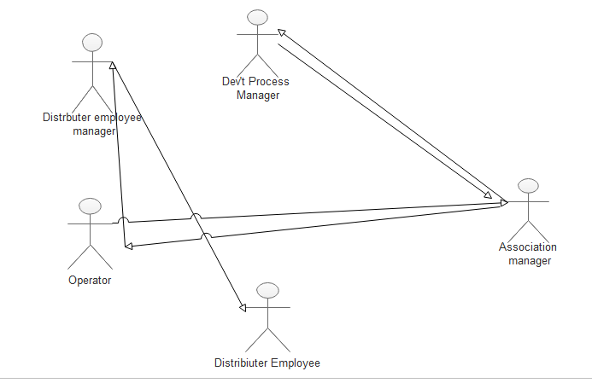
Figure 2.1 Existing System Workflow diagram

To do these, the activities follow the following procedures. These are:
- The operator asks for membership questions for the association manager.
- Then the association manager accepts membership request if it fulfills the property.
- And the association after accepting send to the development process,
- The development process approves the membership question. After this the operator is an association member then the cooperative and distributer manager assigns the workplace.
- If the operator went to change the workplace to ask the association. If the association gives permission for the operator to change workplace or schedule.
- Every month, officials of Transport Cooperator and Distributor (Simirit Yesira Hidet) assign the buses that go to specific areas including their leaving time and the buses are expected to follow this arrangement until the end of the month in which new arrangement is done.

Major functions/activities in the existing system like inputs, processes & outputs
Input: -
The organization takes the following components as input to provide the bus station to the customer.
- Register new bus and association information.
- Formed associations.
- Register new employees.
Processes: -
The organization performs the following operations while proving the bus station to the customer.
- Verifying bus information
- Reserve the bus turn.
Outputs: -
After taking the above inputs and processing them the organization will provide the following results or outputs.
- Post the schedule of the bus

2.4 Business Rule
A business rule is a statement that expresses some aspects of the business. It is intended to assert business structure or to control the behavior of the business. It describes the operations, definitions, and constraints that apply to an organization in achieving its goal.
Kombolcha Bus Station has the following business rules for each component of the bus station.
These are:
For operator: one operator comes to a member of association he/she must have:
BR1: he/she have an operator license with their level
BR2: he/she must third party insurance member
BR3: the operator must have a business license.
BR4: must have liebry
BR5: after this can ask membership request from the association.
For Association: to formed once association:
BR1: must have their own human power.
BR2: must have their own structure
BR3: for level one number of members is greater than 20, for level two greater than 30, and level three greater than 40.
BR4: after this to ask the development process then the development process can view and approve.
BR5: final register associations.
BR6: then this registered association can view distributer employees.
BR7: distributer employee see the availability and then register the bus information
BR8: assign to available space.

2.5 Report generated in the existing system
To control and manage all activities of the organization, the report must be generated, to achieve its objectives. It has different reports about its regular activities. Reports are generated tediously and it takes time to be done, it indicates the performance and profitability of the Kombolcha bus station and it should change the way the organization works to improve its service and to assure the quality of bus station service. These reports are generated by the distribute employee manager who prepares the schedule and generates the report.
Some report is a list below.
- schedule.
- Each operator identification number and bord number.

2.6 Bottlenecks of the existing system

2.6.1 Performance (Response time)
As long as the existing system is depending on a manual method, it performs tedious and time-consuming tasks. Hence, the response time is very slow because they only use manpower for doing every process.

2.6.2 Input (redundant/flexible) and Output (Inaccurate)
The existing system uses mainly paper, pen, and ruler as Input and processed it to give better service in the bus station.

2.6.3 Security and Controls
In the existing system, the method they use to enhance security is to store data redundantly in different offices, and in every progression, those offices evaluate and contrast each other. It's not as secured as enough. Also, it consumes time and human power.

2.6.4 Efficiency
As we mentioned earlier, the Kombolcha bus station has many problems such as bus registration on paper, so, it leads to inconsistency of data and customers don't have the opportunity to get updated information on time. I.e., since there is a manual information communication system, sometimes the information that is already distributed for the customer may be modified, deleted, or changed so that such new information for the bus is not easy to access.

2.7 Proposed System
By carefully analyzing and observing the problem of the existing system we came up with a solution that the current manual system should be computerized. The computerized system eliminates/reduces the problem on time, workload. To develop a web-based management system. It can easily solve the problem. So that the proposed system also has the following similar scope and functionality with the existing system.

To solve the problem by using database connection can upload necessary information, update, delete, search, and view data easily, this system can solve the listed problem and save resources. Because the existing system extravagant for resources. The main function of the proposed system is easily to do their work for any workers who are found in the bus station. And the system administrator can manage easily forever employees found in the bus station and associations. It is used to save time and check the performance of the bus and save the data confidentially without any disorder and error. The system is very simple in design and to implement. The system requires very low system resources and the system work in almost all configurations. It has got following features
- Ensure data accuracy.
- Minimize manual data entry.
- Minimum time needed for the various processing
- Better Service
- Minimum time required etc.
Diagrammatically the workflow of the proposed system is like this:
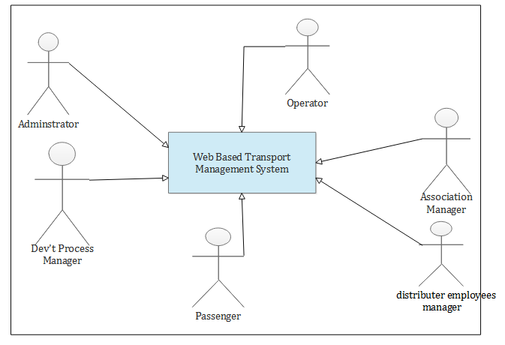
Figure 2.2 Proposed system diagram

2.8 Requirement Analysis Proposed System
The method of requirement gathering we conducted for this project work were observation, interview, and questioner. Since the organization or the bus station is not comfortable undertaking other requirement gathering methods, we have undergone the above three only. An interview was performed using semi-structured question two officials in the office. The two officials are select based on stratified sampling because we use this type of sampling was good and better than random sampling and the selection was based on education level. It was aimed to get detailed information about the functioning of the existing system and general background information about the bus station.

The observation was also undergone to know the overall functioning of the existing system. This data gathering method is best for others because easy to understand how the existing system works. We understand more than of interviewing and questioning method.

The other data gathering method was questioners. This data, gathering method was to select some distributer employees and other officials based on a stratified sampling method. Because we used this selection method was based on education level. The questionnaires were prepared based on official and distributer language, then the official and distributer are easily understood the questionnaires and give correct information about the bus station. This data gathering method was semi-structured. Because to get more information about the bus station the official and distributer must understand the question and give correct information.

2.8.1 Functional Requirement
Functional requirements are a statement of capability that the system must generate for addressing the business needs that the system must satisfy. Functional requirements define what a system is supposed to do. Our system is initiated to perform the following functional requirements:
- User Account Management I.e. create, Activate, deactivate and edit user accounts.
- Login and logout into the system.
- System users can search for different information if it is necessary.
- Registering new buses and Associations (Mahiberat)
- View different user’s requests
- Record available buses and related information
- Accepting and approving the membership request.
- Reply requests and form members.
- Prepare a schedule and update it
- Approve request
- Post schedule
We specify our system functional requirements based on the following requirements.
Level of functional requirements: - this is FREQ. n when n is 1, 2, 3….
Requirement:- a general statement of the system requirement
Description:-brief description of the requirement.
Category:-types of actors that use this required functionality.
Priority: - Values of the requirement, it may be high, medium, or low.
Based on this measurement we describe in detail our Web-Based Transport Management System functional requirements as follows.
Table 2.1 Functional requirement description
FR ID | Requirement Description | Use case | Priority
01 | The system shall allow to Admin manage all system user account | Activate,Deactivate Account | High
02 | The system must allow login to the system | Login | High
03 | The system shall allow to search information | Search | medium
04 | The system shall allow to register information about bus and association | Register association, Register bus | High
05 | The system shall view necessary information | Bus information, association information,prepared schedule, available bus | medium
06 | the system shall upload some available bus and their information. | Upload | High
07 | The system shall support the association manager to accept and the development process manager to accept and approve the request. | Send Request,Accept Membership Request | high
08 | The system shall support the operator to send requests and the association manager formed their members. | View,Formed Members | High
09 | The system shall support the distributer Employee manager to prepare a schedule and update it. | Prepare Schedule,Update Schedule | High
FREQ 1.
Requirements: the system shall to allow the system administrator can handle or manage all system users’ accounts.
Description: This task is done and manipulated by the system administrator. Therefore, the system administrator can create a user account, deactivate user account, update user account information and change the privileges of the users. Account update is not only manipulated by system administrators but also other system users can manipulate except passengers.
Category: System Administrator.
Priority: high
FREQ 2.
Requirements: the system shall support all system uses to login and logout to the system except to passengers.
Description: when the system users need to use this system must login to the system. Login to the system user name and password is required. After login to perform its task and logout to the system.
Category: all system users except passengers.
Priority: high
FREQ 3.
Requirements: the system shall support some system users to search for different information.
Description: different system users can search different information if it is necessary such as system Administrator can search during deactivate, updating user account, and access different information. And the distributer employee-manager also searches different information to view association information.
Category: System Administrator, Distributor Employee manager, passenger.
Priority: medium
FREQ4.
Requirements: the system shall the registered different information such as new buses and Associations (Mahiberat).
Description: when new buses and Associations enter the bus station as a member, the system should allow users to record all information regarding these buses and Associations (Mahiberat). This is helpful for data manipulation and management.
Category: for bus information Distributer Employee Manager and Association Development Process Manager.
Priority: high
FREQ 5
Requirements: the system shall to some system users view the same necessary information.
Description: the system users can view detail of different information such as bus information, association information, prepared schedule, available bus, and other information are viewed by different system users based on their function.
Category: all system user except system administrator but all system users see different information
Priority: Medium
FREQ 6
Requirements: the system shall upload some available bus and their information. Description: the distributer employee-manager upload different available bus with their tariff and other information.
Category: Distributer Employee Manager
Priority: high
FREQ 7
Requirements: the system shall support the association manager to accept and the development process manager to accept and approve the request.
Description: This task is done and manipulated by the association manager and development process manager. The association manager accepts the membership request of the operator and sends it to the development process manager and the development process manager approves the membership request.
Category: Association Manager to accept and Development process manager to accept and approve.
Priority: high
FIRE 8
Requirements: the system shall support the operator to send requests and the association manager formed their members.
Description: This task is also done and performed by the operator and association manager. The operator sends a membership request to the association manager then the association manager view and formed members.
Category: Operator to send request and Association Manager. Priority: high
FREQ 9
Requirements: the system shall support the distributer Employee manager to prepare a schedule and update it.
Description: the Distributer Employee manager can prepare the bus schedule and update it if necessary
Category: Distributer Employee manager
Priority: high

2.8.2 Nonfunctional requirements
These are the requirements that are not directly related to the system but still are important as equal as functional requirements to the system. They describe user-visible aspects of the system that are not designed for the functional behavior of the system. The following are some of the non-functional requirements for our system. These are:
Table 2.2 Nonfunctional requirement description
NFR ID | Requirement Description | Requirement Group
01 | The load time for the user interface screens shall take no longer than two seconds. Queries shall return results within five seconds. | Performance
02 | The system can run on different platforms | Portability
03 | The system shall be available via an internet connection | Availability
04 | Access to the system will be protected by a user login screen that requires a user name and password. | Security.
05 | The system should be user friendly | Usability
- Security issues: Any system user shall never login to another system user. This secured each system interface from accessing authorized users through authorized the database table only for that user who has special privileges.
NB: we use authentication/access limit for providing security for the system.
- Quality issue: The system reliable and accurate in providing information to the users. Since our system should include functional and non-functional requirements and then it deals with quality.
- Accuracy: The level of accuracy in the proposed system better due to the reduction of error. The system should give correct output for the users when they want to get services.
- Error handling: When the user makes some mistakes the system responds that the error is occurred using easily understandable messages and allows the user to recover from the error. In developing our project we use different event and error handling techniques provided by javascript and PHP to validating data, and hence errors handled and only accepted correct data.
- Simplicity: The system should be easy to use and also simple to manipulate. This could be made possible through the use of different user-friendly interfaces. Our System is being developed in PHP.
- Performance: as much as possible, the system gives a response to the users in 20 minutes without delaying much time.
- Availability: the system has been available at any time for users regarding the presence of electric power and intranet. By using a redundant server to protect the downtime of the system.
- Resource: consumes fewer resources like time, the power needed to perform the task.
- Accessibility: the system is accessible to Internet-enabled devices.
- User-friendly interface: the user interface has an attractive color selection, user can easily input and retrieve their profile and their data.
- Maintainability: the system is easy to modify and to add functionality without affecting the general framework of the system.
- Operating system: the system can be deployed in Windows OS or Linux OS.
- Usability: In this case, our system possesses the following regarding usability:
- Easier to learn: operation can be learned by observation. So it is more satisfying to use.

2.8.3 System Requirement

2.8.3.1 Hardware Requirement
The main role development process manager is to control all activity of the association, approve the

- Computer with specification of Intel(R) Core(TM) i5-2120 CPU 3.30GHZ. Used to write our proposal, documentation, develop web-based transport management system in Kombolcha bus station and used for doing of other things.
- Installed Physical Memory (RAM) 4.00 GB
- Smartphone for data recording during data collection
- 8GB Flash, Memory. Used to backup data storage.
- Paper used to prepare questionary and print project documents.
- 3 Pens used for data gathering, and Darrow use case and other diagrams on paper (blueprint).

2.8.3.2 Software Requirements

- MS Office 2010 for word processing: to write the project documentations, questionary.
- MS PowerPoint 2010:- to prepare a presentation.
- Snapping tool:- used to snapping different project figures
- Adobe Photoshop cs5:- used to design, write, and decor different images

2.9 Modeling the existing systems

2.9.1 Essential Use Case Modeling
We use an essential use case diagram to present the functionality of the system from the actor's point of view. We use a case model diagram to show graphically the system scope and boundaries as well as to represent the relationships between the actors and use cases. This UML diagram describes a function provided by the system that yields a visible result for an actor.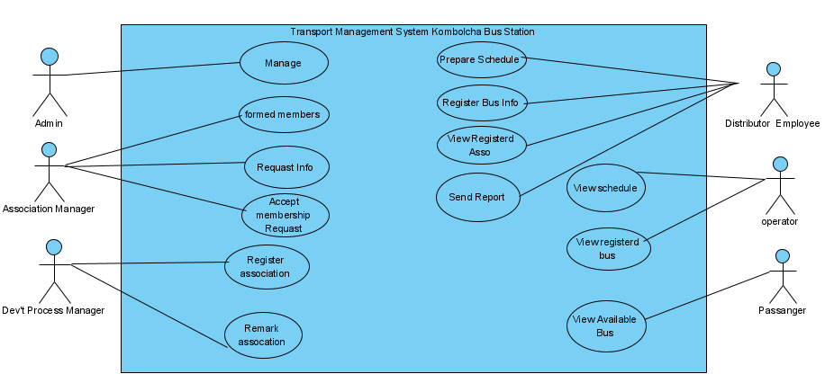
Figure 2.1 Essential use case diagram

2.9.2 Essential User Interface Prototyping
An essential UI prototype is a prototype of UI for the system that is essential for the system to view system users. It represents the general idea behind the UI, but not exactly the details. It also represents UI requirements in a technology-independent manner to gather more requirements from system users.
Registration form
First name:
Middle name:
Last name:
Sex: female
Male
Keble:
User identification Number:
Phone Number:
Keble Identification card:

2.9.3 Essential User Interface Prototyping flow diagrams
User interface (UI) prototyping is an iterative development technique in which users are actively involved in the mocking-up of the UI for a system a basis from which to explore the usability of your system. A vehicle for you to communicate the possible UI design(s) of your system and potential foundation from which to continue developing the system (if you intend to throw the prototype away and start over from scratch then you don't need to invest the time writing quality code for your prototype).
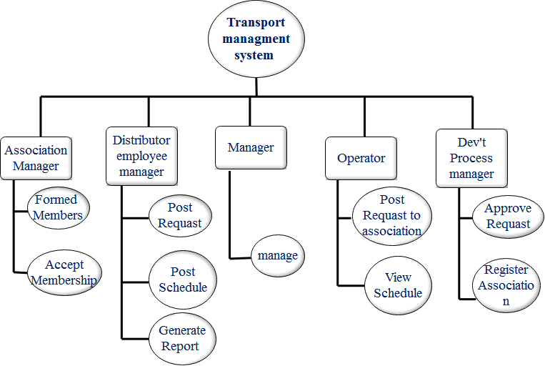
Figure 2.2 Essential user interface prototyping flow diagram.

2.9.4 Domain modeling with class responsibility collaborator (CRC)
CRC is a collection of standard index cards that have been divided into three sections. A class represents a collection of similar objects. The name of the class appears across the top of the card. A responsibility is something that a class knows or does.
Responsibilities are shown on the left-hand column of a CRC card. A collaborator is another class that a class interacts with to fulfill its responsibilities. Class responsibility collaborator (CRC) shows the classes and their collaborators that exist in the system as well as their responsibility.
A class represents a collection of similar objects; while responsibility is something that a class knows or does and a collaborator is another class that a class interacts with to fulfill its responsibilities.
Table 2.1 Collaboration modeling for Admin
Admin<<Actor>>
First Name  Last Name  Id  Phone number  Email  manage() | Distribute employee manager<<Actor>  Dev’t process manager<<Actor>>  Association manger<<Actor>>  Operator<<Actor>>

Table 2.2 Collaboration modeling for an Association manager
Association manager<<Actor>>
First Name  Last Name  Id  Phone number  Accept request()  View report()  Generate report()  Formed association() | Operator<<Actor>>  Dev’t process manager<<Actor>>

Table 2.3 Collaboration modeling for Employee
Distribute employee<<Actor>>
Name  Id  Phone number  Email  Prepare schedule()  View association()  Registered bus info() | Operator<<Actor>>  Passenger<<Actor>>

Table 2.4 Collaboration modeling for Dev’t process manager
Dev’t process manager<<Actor>>
Name  Id  Phone number  Email  view report ()  Approve association()  Register association() | Association<<Actor>>  Operator<<Actor>>

Table 2.5 Collaboration modeling for Passenger
Passenger<<Actor>>
First Name  Last Name  Id  Address  View available bus info()  View association() | Operator<<Actor>>

Table 2.6 Collaboration modeling for Operator
Operator<<Actor>>
First Name  Last Name  Id  Address  View his schedule()  View available bus info()  View association() | Association manager<<Actor>>  Passenger<<Actor>>

Chapter Three

System Analysis (Modeling the Proposed System)

3.1 Introduction
System analysis is a process of collecting and interpreting facts, identifying the problems, and decomposition of a system into its components. It is the part of the systems development life cycle in which you determine how the current information system functions and assess what the user would like to see in the new system.

3.2. Modeling proposed systems

3.2.1 System use case diagrams
A use case diagram describes how a system interacts with outside actors. It is a graphical representation of the interaction among the elements and system. Use case identifies the functionality of a system.
The use case diagram models the user’s expectation for using the system. The people and systems that interact with the system are called the actors. The features of the system that the actors use are called the use cases.
- Use cases. A use case describes a sequence of actions that provide something of measurable value to an actor and is drawn as a horizontal ellipse.
- Actors. An actor is a person, organization, or external system that plays a role in one or more interactions with your system. Actors are drawn as stick figures.
There are 26 use cases in this System:
Use case 1: Security login
Use case 2: Update Account
Use case 3: Create Account
Use case 4: Deactivate Account
Use case 5: Activate Account
Use case 6: View Report
Use case 7: Search Information
Use case 8: Formed members
Use case 9: Accept membership Request
Use case 10: Approve Request
Use Case 11: Register Association
Use Case 12: Remark Association
Use Case 13: Prepare Schedule
Use Case 14: Update schedule
Use Case 15: Upload Available bus
Use Case 16: Register Bus information
Use Case 17: View Registered Association
Use Case 18: Generate Report
Use Case 19: Send Request
Use Case 20: View Association information
Use Case 21: Search Bus information
Use case 22: View registered bus information
Use case 23: View Schedule
Use case 24: Search
Use case 25: View Available bus
Use case 26: Logout
Identified actors that participating in the system are:-
- Administrator
- Distributer Employee Manager
- Dev’t process manager
- Operator
- Association manager
- Passenger
Table 3.1 Actor description
Actors | Description
System Administrator | An employee Manages a user account.
Development process manager | An employee in the office who approve association request.
Operator | A person who has a bus or owner
Distributer employee manager | An employee who performs different activities in the bus station such as prepare schedule, upload available bus with its information.
Association manager | An employee who formed associations.
Passenger | A person who travels from one place to another place.

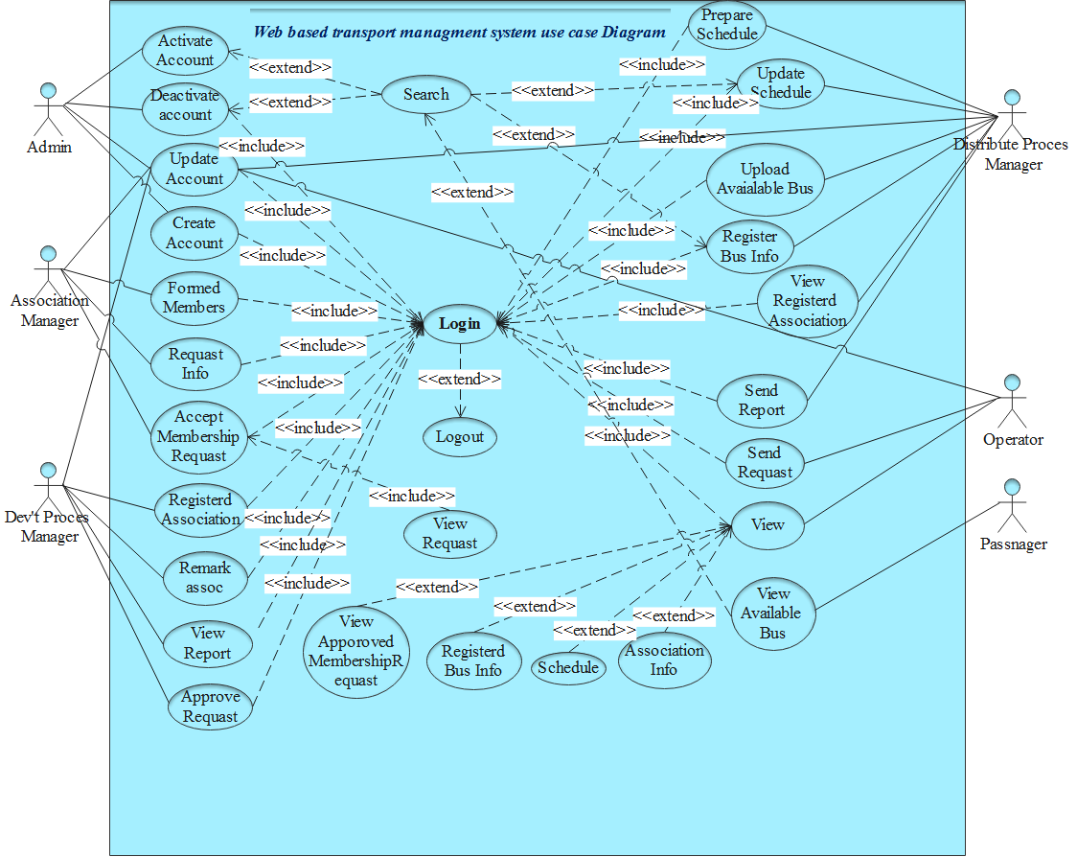
Figure 3.1 Use case diagram

3.2.2 Use case Descriptions
Below are the lists of the use cases that are identified for the Kombolcha bus station transport management system. The system use case description contains:

- Use case name
- Use case identification number
- Actor
- Extends
- includes
- Description
- Pre-condition
- Postcondition
- Basic course of action
- An alternative course of action
Table 3.2 Login use case description
Use case Name | Login
Use case ID: | UC 01
Description: | Login is used to authenticate and validate system users so that only valid users can have access to the system.
Actor: | All users of the system except passengers.
Pre-condition: | All users must have an account.
Postcondition : | Users login to the user’s page
Extends: | Logout
Includes:
Basic course of action: | - User requests to login into the system.  - The system displays a user interface to login.  - Users enter their user name and password via the login form and submit the form.  - The system check validation of the user name and password.  - Users login to the system.  - Use case end.
An alternative course of Actions: | inserted user name and password not valid:  - a system verifies user name/password is not valid.  - The system continues at step 3 of the above basic course of action.

Table 3.3 Use case description of account deactivate
Use case Name | Account deactivate
Use case ID: | UC 02
Actor: | Administrator
Description: | The System Administrator can deactivate user's accounts.
Pre-condition | The administrator must login to the system.
Postcondition: | The administrator will deactivate the user account.
Extends: | UC 05
Includes: | UC 01
Basic course of action: | - The Administrator login to the system.  - The administrator requests to deactivate the user account.  - The system displays a user interface to deactivate the user account.  - The administrator searches the user id or name of the employee.  - The administrator clicks on deactivate button.  - The system asks the actor whether he/she sure wants to deactivate.  - The administrator clicks the button that shows sureness.  - The system display that the user account is successfully deactivated.  - Use case end.
An alternative course of action: | A. If invalid data entry.  A1. The system displays the error message to the user.  A2. The system prompts the administrator to go to step 4 the basic course of action.

Table 3.4 Use case description of Account Update
Use case Name : | Update account
Use case ID: | UC 03
Actor: | All system users except passengers.
Description: | All system users can update/edit their accounts except passengers.
Pre-condition: | Login to the system.
Postcondition: | The users update their accounts.
Extends: | UC 05
Include: | UC 01
Basic course of action: | - The user login to the system.  - The user clicks on the update account button.  - The system displays an updated account form.  - The users enter all required information for updating information.  - The user submits information.  - The system checks the entered information validates.  - The information is valid then the system authenticates from the database.  - Authentication is true the system display the account update successfully.  - Use case end.
An alternative course of Action: | If there is a mistake in the input.  A.1 the system displays an error message and allow correcting.  A2. The user goes to step 4 for basic course action.  A3. There is no account before.

Table 3.5 Use case description of Account Create
Use case Name | Account create
Use case ID: | UC 04
Description: | The system administrator creates the user account.
Actor: | System Administrator.
Pre-condition: | Must login to the system.
Postcondition : | Admin create a user account and it has account privileges.
Extends:
Includes: | UC 01.
Basic course of action: | - The administrator login to the system.  - The administrator clicks on the create account button.  - The system display creates an account form.  - The administrator enters all required information to create an account.  - The administrator submits the information.  - The system check validates the information.  - The system display a message account created successfully.  - Use case end.
An alternative course of Actions: | If there is a mistake in the input.  - the system displays an error message and allows correcting.  - the system admin goes to step for and try again.

Table 3.6 Use case description of Search
Use case Name | Search
Use case ID: | UC 05
Actor: | System Administrator, Distributor Employee Manager and  passenger
Description: | System administrators, passengers, and distributer Employee managers can search for different information if it is necessary.
Pre-condition: | Users must login to the system.
Postcondition : | See different information by searching.
Extends:
Includes: | UC 01
Basic course of action: | - The actor login to the system.  - The actor clicks the search button.  - The system display search form and information.  - The actor enters the key identifier of the entity to be searched.  - The system performs the intended task.  - Use case end.
An alternative course of Actions: | A. If the searching data was not found.  A1.The system display message the data does not exist.  A2. System actors reenter the data by going to step 3 of the basic course of action.

Table 3.7 Use case description of View report
Use case Name | View Report
Use case ID: | UC 06
Description: | The development process manager view generated report.
Actor: | Development process manager.
Pre-condition: | Must login to the system.
Postcondition : | View the report.
Extends:
Includes: | UC 01.
Basic course of action: | - The development process manager login to the system.  - The manager clicks on the view report button.  - The system display report.  - The manager sees all the required information.  - The system passively viewed the report.  - Use case end.
An alternative course of Actions: | If the system displays the report.  A1. The manager going to again step 2 in the main course of action.

Table 3.8 Use case description of Formed members
Use case Name | Formed members
Use case ID: | UC 07
Actor: | Association manager.
Description: | An association manager can form an association.
Pre-condition: | Login to the system
Postcondition : | Formed association.
Extends:
Includes: | UC 01
Basic course of action: | - The Association manager logs in to the system.  - The manager clicks the formed member link.  - The system displays the formed member form.  - The association manager enters the necessary information.  - The system performs the intended task.  - The system display message association is formed  - Use case end.
An alternative course of Actions: | A. If the association is not formed.  A1. The system displays an error message.  A2. The association manager reenters the data by going to step 3 of the basic course of action.

Table 3.9 Use case description of Request information
Use case Name | Request information
Use case ID: | UC 08
Actor: | Association manager.
Description: | Association manager can send request/ formed association  information to the development process manager.
Pre-condition: | The association manager must login to the system.
Postcondition : | Send a request to the development process manager.
Includes: | UC 01
Basic course of action: | - The association manager login to the system.  - The association clicks the request button.  - The system display request form and information.  - The association manager sends the request.  - The system performs the intended task.  - The system displays the message the data send.  - Use case end.
An alternative course of Actions: | A. If the request is not send  A1. The system displays an error message.  A2. The association manager rework.

Table 3.10 Use case description of accept membership request
Use case Name | Accept membership request
Use case ID: | UC 09
Actor: | Association manager.
Description: | The association manager accepts every operator's request.
Pre-condition: | The association manager must login to the system.
Postcondition : | Accepting operator request.
Extends: | UC 21
Includes: | UC 01
Basic course of action: | - The association manager login to the system.  - The association manager click accepts membership request button.  - The system display accepts membership request forms and information.  - See and accept the operator's request.  - The system performs the intended task.  - Send a message to operator request accepted.  - Use case end.
An alternative course of Actions: | If the request is not accepted  A1. The system displays an error message.  A2. The association manager reworks the above process.

Table 3.11 Use case description of Approve request
Use case Name | Approve request
Use case ID: | UC 10
Actor: | Development process manager.
Description: | The development process manager can approve the request.
Pre-condition: | The development process manager must login to the system.
Postcondition : | Approve association membership request.
Extends: | UC 21
Includes: | UC 01
Basic course of action: | - The development process manager login to the system.  - Then click the approved request.  - The system display requests information from the association manager.  - The development process manager clicks to approve request button.  - The system performs the intended task.  - The system displays a successful message to approve the request.  - Use case end.
An alternative course of Actions: | A. If is not approve the request.  A1. The system displays an error message  A2. The development process manager re-approves the request.

Table 3.12 Use case description of register association
Use case Name | Register association
Use case ID: | UC 11
Actor: | Development process manager.
Description: | The development process manager can register an association.
Pre-condition: | Login to the system.
Postcondition : | Register association.
Extends:
Includes: | UC 01
Basic course of action: | - The development process manager login to the user’s page.  - The development process manager clicks the registered link.  - The system displays the registration form and information.  - The manager enters the necessary information.  - The system authenticates the entered data.  - Click on submit button.  - The system display message of the data successfully registered.  - Use case end.
An alternative course of Actions: | If the information is not registered  A1. The system display error message data that is not registered.  A2. The manager rework/re-register.

Table 3.13 Use case description of prepare schedule
Use case Name | Prepare schedule
Use case ID: | UC 12
Actor: | Distributer employee manager
Description: | Distributer employee managers can prepare a schedule.
Pre-condition: | The distributer employee must login to the system.
Postcondition : | To prepare a schedule.
Extends:
Includes: | UC 01
Basic course of action: | - The distributer employee-manager must login to the system.  - Then click the schedule button  - The system display schedule form  - The manager enters the necessary information.  - The system authenticates the entered information.  - Use case end.
An alternative course of Actions: | If the entered information is invalid.  A1. The system displays an error message.  A2. The distributer employee-manager prepare again.

Table 3.14 Use case description of update schedule
Use case Name | Update schedule
Use case ID: | UC 13
Actor: | Distributer employee manager
Description: | Distributer employee-manager can update schedule.
Pre-condition: | The distributer employee-manager must login to the system.  Must have prepared /old schedule
Postcondition : | To update schedule.
Extends: | UC 05
Includes: | UC 01
Basic course of action: | - The distributer employee-manager must login to the system.  - Then click the schedule update button  - The system display update form  - The manager can enter key identification of the entity want to update can search.  - The manager enters the necessary information.  - The system authenticates the entered information.  - The system displays a success message.  - Use case end.
An alternative course of Actions: | If the entered information is invalid.  A1. The system displays an error message the entered information is not valid.  A2. The distributer employee-manager re-update again.

Table 3.15 Use case description of upload available bus
Use case Name | Upload available bus
Use case ID: | UC 14
Actor: | Distributer employee manager
Description: | Distributer employee-manager upload available bus on the  web site.
Pre-condition: | The distributer employee-manager must login to the  system.
Postcondition : | Upload available bus.
Extends:
Includes: | UC 01
Basic course of action: | - The distributer employee-manager must login to the system.  - Then click the upload button  - The system displays the upload form  - The manager can select available buses and type their necessary information.  - Click to upload.  - The system displays a success message.  - Use case end.
An alternative course of Actions: | If the entered information is upload.  A1. The system displays an error message the entered information is not uploaded.  A2. The distributer employee-manager re-uploads again.

Table 3.16 Use case description of registered bus information
Use case Name | Registered bus information
Use case ID: | UC 15
Actor: | Distributer employee Manager
Description: | Distributer employee Manager registered bus information.
Pre-condition: | The distributer employee Manager must login to the  system.
Postcondition : | The distributer employee-manager registered bus  information.
Extends:
Includes: | UC 01
Basic course of action: | - The distributer employee-manager must login to the system.  - The click registered link.  - The system displays the registered form  - The employee-manager fills the form/enters the required information.  - The system verifies the inserted information.  - The system displays a success message.  - Use case end.
An alternative course of Actions: | If the entered information is invalid.  A1. The system displays an error message the entered information is not valid.  A2. The distributer employee-manager goes to step 4 of the main course of action and tries again.

Table 3.17 Use case description of view registered association
Use case Name | View Registered Association
Use case ID: | UC 16
Actor: | Distributer employee manager
Description: | Distributer employee-manager view registered association.
Pre-condition: | The distributer employee-manager must login to the system.
Postcondition : | View registered association.
Extends: | UC 05
Includes: | UC 01
Basic course of action: | - The distributer employee-manager must login to the system.  - Then click the view button  - The system display information  - Use case end.
An alternative course of Actions: | If the system does not display information.  A1. The distributer employee-manager going to step 2 and try again.

Table 3.18 Use case description of generating a report
Use case Name | Send report
Use case ID: | UC 17
Actor: | Distributer employee manager
Description: | Distributer employee-manager generate information and  send to the development process manager.
Pre-condition: | The distributer employee-manager must login to the system.
Postcondition : | Generate and send the report.
Extends:
Includes: | UC 01
Basic course of action: | - The distributer employee-manager must login to the system.  - Then click generate button  - The system generates a report.  - Send the report to the development process manager.  - Use case end.
An alternative course of Actions: | If the system is no generated.  A1. The system displays an error message.  A2. The distributer employee-manager going to step 2 on the main course of action and try again.

Table 3.19 Use case description of send request
Use case Name | Send request
Use case ID: | UC 18
Actor: | Operator
Description: | The operator sends membership request to the association  manager.
Pre-condition: | The operator must login to the system
Postcondition : | Send request.
Extends:
Includes: | UC 01
Basic course of action: | - The operator login to the system.  - Click on the send request button.  - The system displays the request form.  - The operator inserts information.  - Click on the send button.  - The system verifies the inserted information.  - System display message the request is sent.  - Use case end.
An alternative course of Actions: | If the entered information is invalid.  A1. The system displays an error message the entered information is not valid.  A2. The operator going to step 4 on the main course of action and try again.

Table 3.20 Use case description of the view
Use case Name | View
Use case ID: | UC 19
Actor: | Operator
Description: | Operator views prepared schedule, updated schedule,  registered bus information, and association information.
Pre-condition: | The operator must login to the system
Postcondition : | Vies different information.
Extends: | UC 12, UC 13, UC 15.
Includes: | UC 01
Basic course of action: | - The operator login to the system.  - Click on the view button.  - Select buttons want to view.  - The system displays the information.  - Use case end.
An alternative course of Actions: | If the system does not display information.  A1. The operator going to step 3 on the main course of action and try again.

Table 3.21 Use case description of view available bus
Use case Name | View available bus
Use case ID: | UC 20
Actor: | Passenger
Description: | The passenger vies the available bus.
Pre-condition:
Postcondition : | Vies available bus.
Extends: | UC 05
Includes:
Basic course of action: | - Visit the system website.  - The passenger selects a city or town.  - The passenger selects the bus level.  - The passenger click on the search button.  - The system displays the available bus types with information.  - Use case end.
An alternative course of Actions: | If the system does not display available bus,  A1. The passenger going to step 2 on the basic course of action and try again.

Table 3.22 Use case description of view request
Use case Name | View request
Use case ID: | UC 21
Actor: | Association manager & Dev’t process manager
Description: | The association manager views the operator's request to add an association. The development process manager also see the  membership request and approval.
Pre-condition: | The operator must login to the system
Postcondition : | Vies different request information.
Extends:
Includes: | UC 01
Basic course of action: | - The Development process and association manager login to the system.  - Click on the view request button.  - The system displays the information.  - Use case end.
An alternative course of Actions: | If the system does not display information.  A1. The operator going to step 2 on the main course of action and try again.

Table 3.23 Use case description of search bus information
Use case Name | Search bus information
Use case ID: | UC 22
Actor: | Passenger
Description: | The passenger can search available bus information
Pre-condition:
Postcondition : | Vies different bus information.
Extends:
Includes:
Basic course of action: | - The passenger browse the website  - Click search button  - enter the city name  - the system displays the available bus with their information  - Use case end.
An alternative course of Actions: | If the system does not display information.  A1. The passenger going to step 3 on the main course of action and try again.

2.2.3 Sequence Diagram
A sequence diagram is one kind of interaction diagram, which shows interaction among a set of objects and their relationships. The purpose of the Sequence diagram is to document the sequence of messages among objects in a time-based view. The scope of a typical sequence diagram includes all the message interactions for a single-use case.
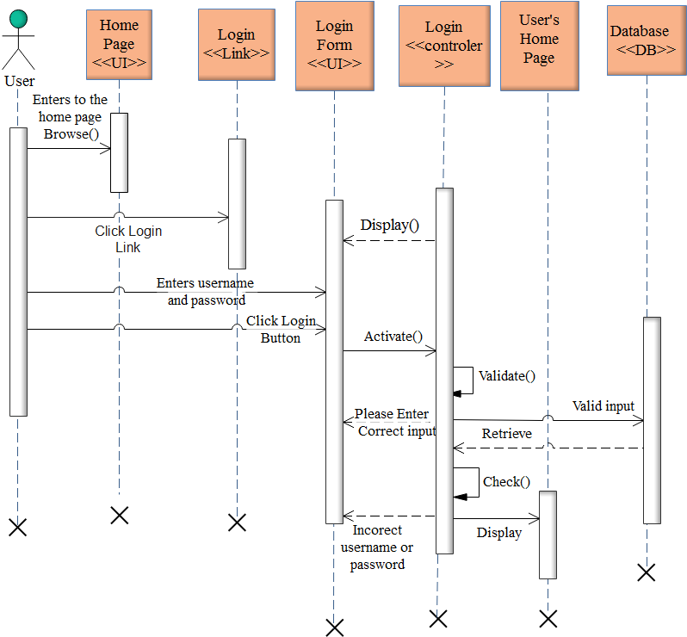
Figure 3.2 Login sequence diagram

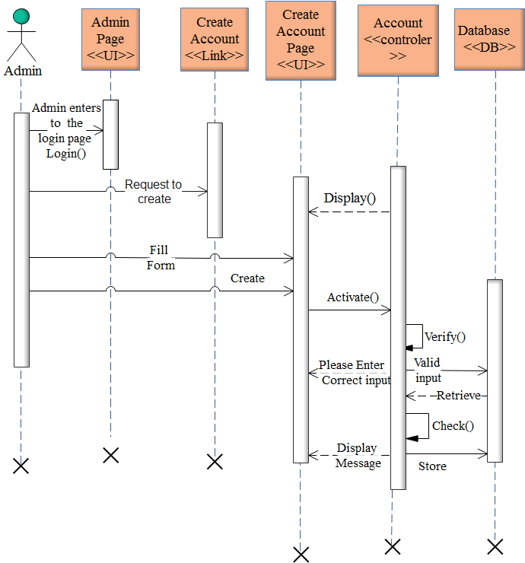
Figure 3.3 Create an Account sequence diagram

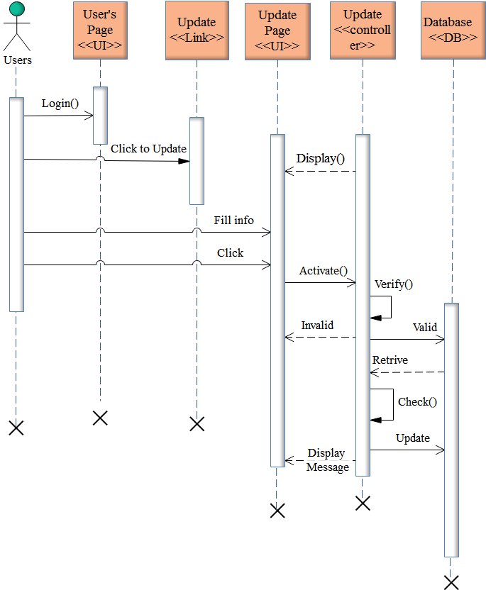
Figure 3.4 Update Account sequence diagram

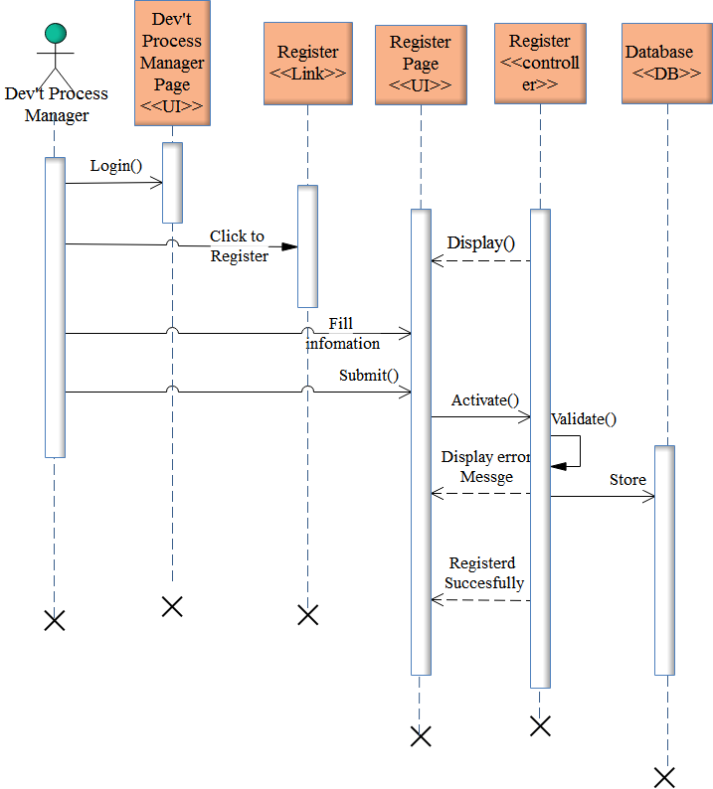
Figure 3.5 Association Register sequence diagram

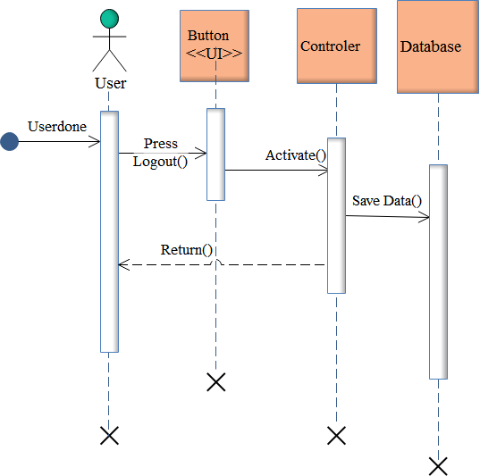
Figure 3.6 Logout sequence diagram

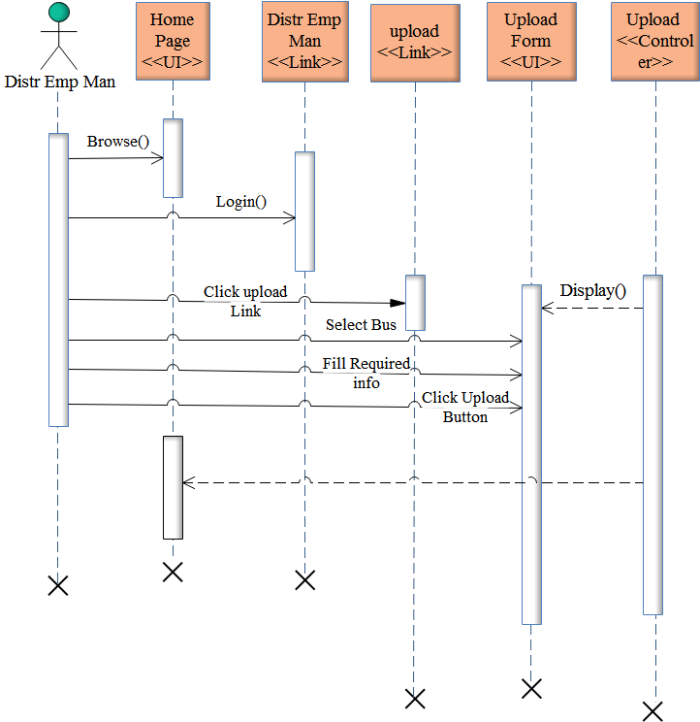
Figure 3.7 Upload Activity diagram

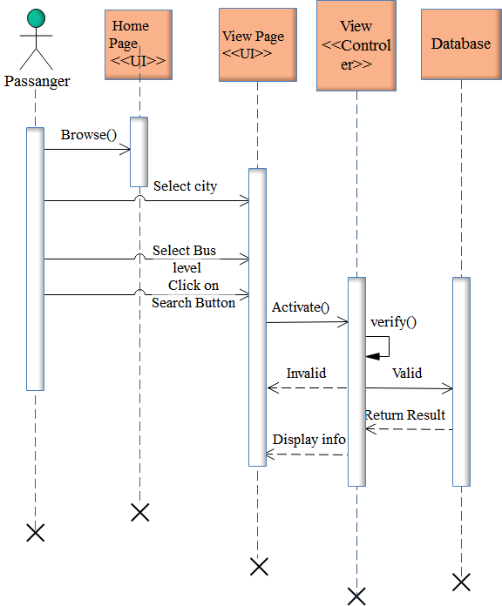
Figure 3.8 View Available bus Sequence diagram

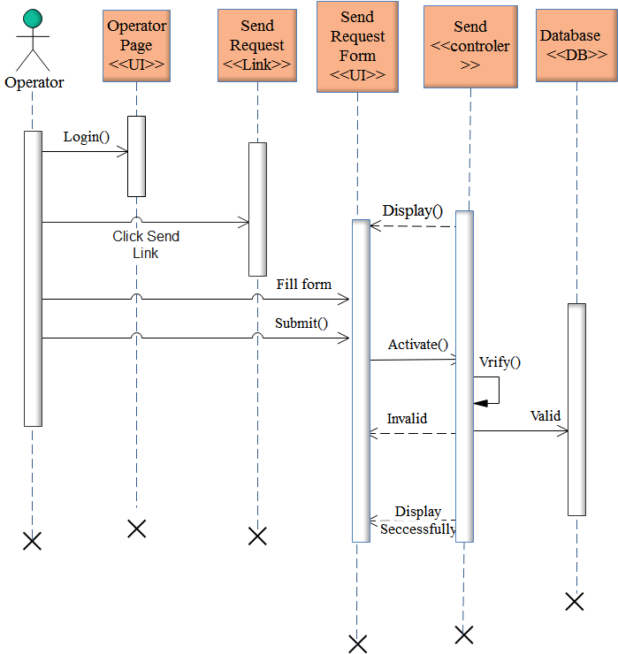

Figure 3.9 Send Request Sequence diagram

3.2.4 Activity Diagram
An activity diagram is used to model a large activity's sequential workflow by focusing on action sequences and respective action initiating conditions. An activity diagram is represented by shapes that are connected by arrows. Arrows run from activity start to completion and represent the sequential order of performed activities. Black circles represent an initial workflow state. A circled black circle indicates an end state. Rounded rectangles represent performed actions, which are described by text inside each rectangle.
A diamond shape is used to represent a decision, which is a key activity diagram concept. Upon activity completion, a transition (or set of sequential activities) must be selected from a set of alternative transitions for all use cases. Synchronization bars indicating the start or completion of concurrent activities are used to represent parallel sub-flows.
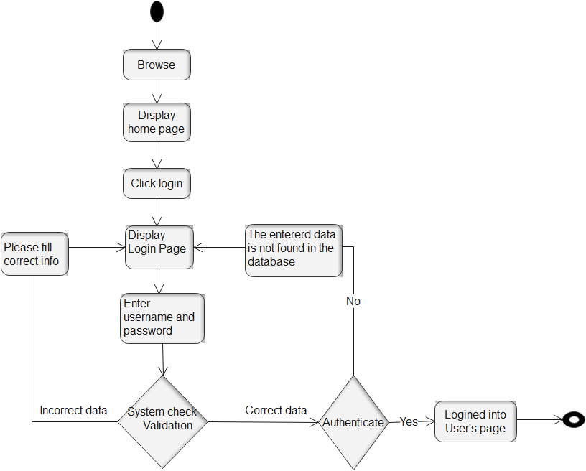
Figure 3.10 Security login activity diagram

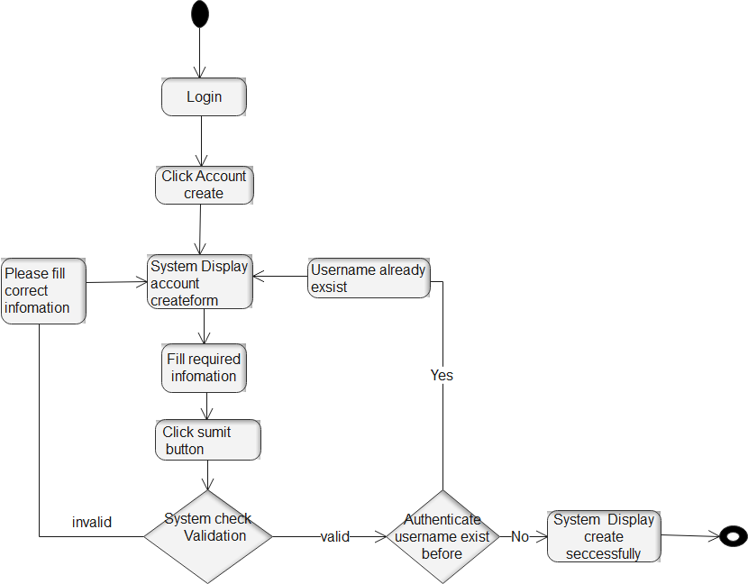
Figure 3.11 Activity diagram of creating account

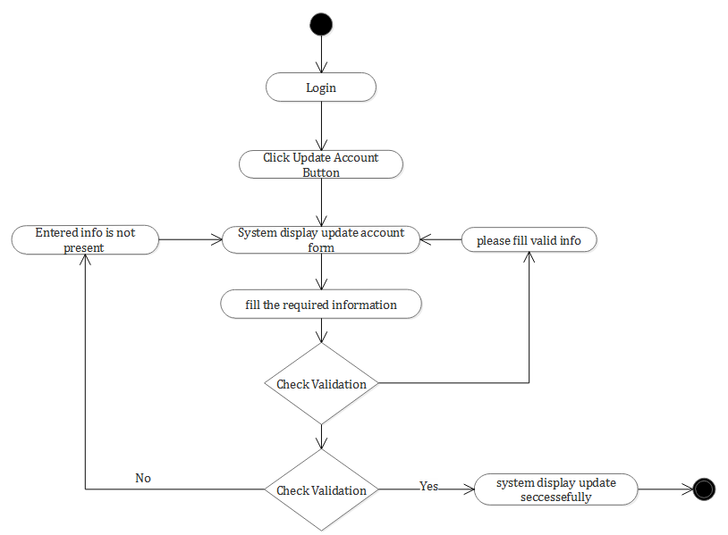
Figure 3.12 Update account activity

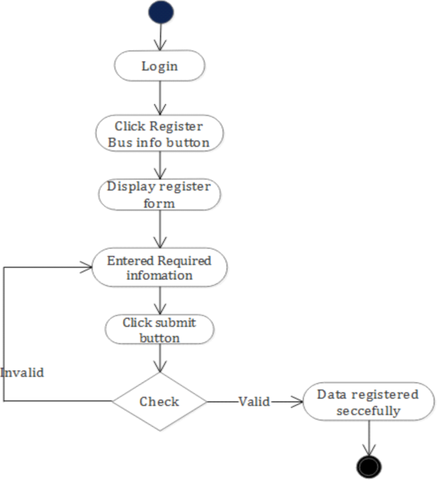
Figure 3.13 Activity diagram of bus information registration

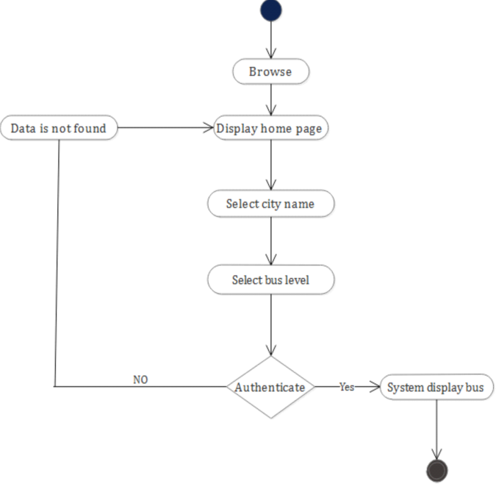
Figure 3.14 Passenger search for available bus

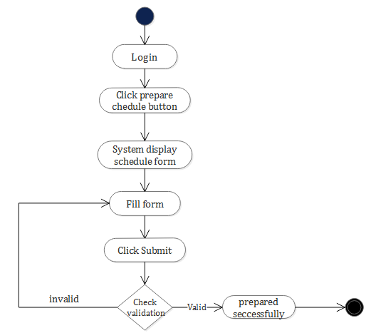
Figure 3.15 Prepare schedule activity diagram

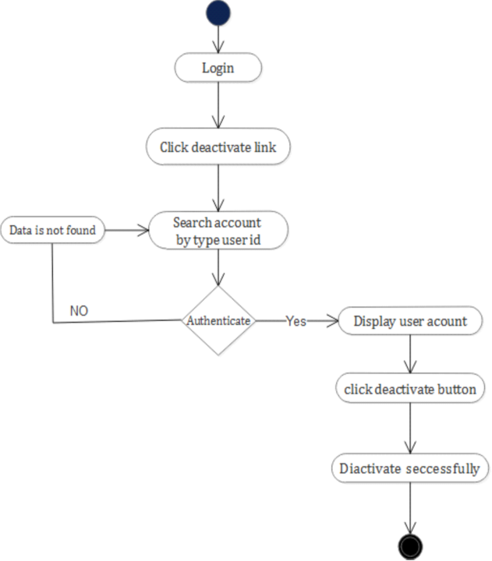
Figure 3.16 Account deactivate activity diagram

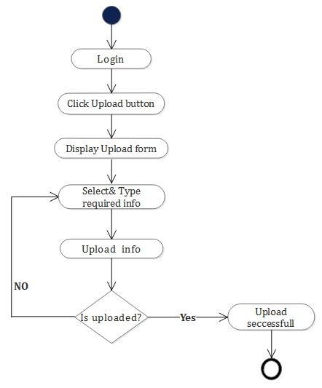
Figure 3.17 Upload Available bus Activity diagram

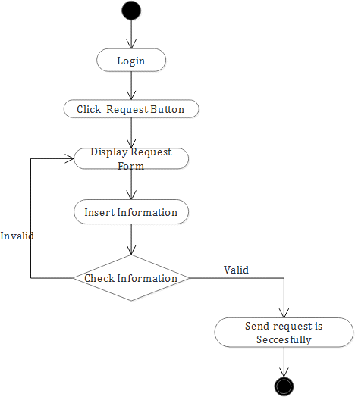

Figure 3.18 Send Request Activity Diagram

Figure 3.19 Approve Request Activity diagram

3.2.5 Analysis level class diagram (conceptual modeling)
The class diagram is a static diagram. It represents the static view of an application. The class diagram is not only used for visualizing, describing, and documenting different aspects of a system but also for constructing executable code of the software application.
The class diagram describes the attributes and operations of a class and also the constraints imposed on the system. The class diagrams are widely used in the modeling of object-oriented systems because they are the only UML diagrams, which can be mapped directly with object-oriented languages.
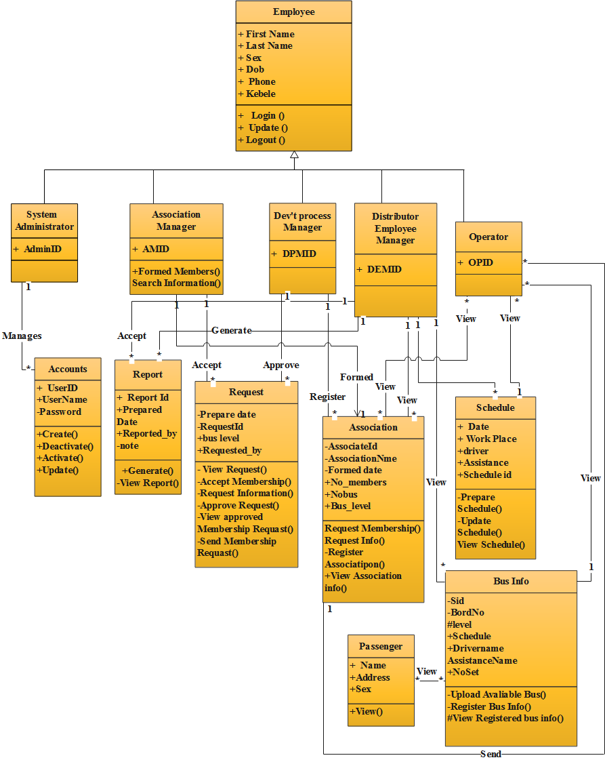
Figure 3.20 Analysis level class diagram (conceptual modeling)

3.2.6 User Interface Prototyping
User interface (UI) prototyping is an iterative development technique in which users are actively involved in the mocking-up of the UI for a system a basis from which to explore the usability of your system. A vehicle for you to communicate the possible UI design of your system and potential foundation from which to continue developing the system (if you intend to throw the prototype away and start over from scratch then you don't need to invest the time writing quality code for your prototype).

Login

User name
Password

Home
Help
Login
View
About As
Request
Contact As

Home page

Contact as
View
Help

Home page
About as
Login
Request

Administrator
Distributor
Employee manager
Operator
Dev’t Process
manager
Association manager
Home

Home

Home

Home

Home

View Schedule Request

c
Schedule
Request
Register Association

Approve Schedule Request
Create account notice
Prepare Schedule
c
Update account
Approve Request

Accept request
Account activate
Post Notice

c
Update Account
Post notice
Account Deactivate
Update Schedule
Update Account
Update Account
c
Post Notice

Report Generate
View Association Us
Post Notice
c
Employee
Register
Update Account
c
View User

Figure 3.21 User Interface Prototyping

Chapter Four

4. System Design

4.1 Introduction
System design is the transformation of the analysis model into a system design model. System design is the first part to get into the solution domain in a software development. This chapter provides the design part of the project is discussed. The system design is the building block of the system. It also transforms the analysis model into system design model. The result of the system design is the model that includes the clear description of software Architecture, Deployment diagram, and system persistent diagram. Generally the purpose of this design phases is to determine how to build the system and the information needed to device the actual implementation of the project.

4.2 Class type architecture
Figure 4.1 Class type architecture

- User interface layer
This Layer is the form which provides the application to either programmer or end user.
- Controller/process layer
This Layer implements business logic that involves collaborating with several domain classes or even other process classes.
- Business/Domain layer
This layer is used to transfer data from application layer or presentation layer to data layer. This layer is also used when a class variables are declared corresponding to the fields of the database which can be required for the application and make the properties. So that, the team can gets or sets the data using these properties into the variables.
- Persistence layer
Encapsulate the capability to store, retrieve, and delete objects/data permanently without revealing details of the underlying storage technology in the system.Often implement between object schema and database schema and there are various available to us.
- System layer
Provide operating-system-specific functionality for our applications, isolating our software from the operating system by wrapping OS-specific features, increasing the portability of your application.

4.2.1 Architectural Design
In this project the team uses a three-tier architecture which has three layers. These three layers are the Application or Presentation layer, the business layer and the data access layer. Application or presentation layer is the form which provides the user interface to either programmer or end user. The business layer is the class which the team uses to write the function which works as a mediator to transfer data from application layer or presentation layer to data layer. This layer also has a property layer which is a class where variables are declared corresponding to the fields of the database which can be required for the application and make the properties so that the team can get or set the data using these properties into the variables. The third tire is the data access layer which is also a class to get or set data to the database queries back and forth. This layer only interacts with the database. The database queries or stored procedures written here to access the data from the database or to perform any operation to the database.

4.3 Design Class Model
Design class modeling is used to model the static structure of how the software is built. In particular, class modeling shows classes, their internal structure, and their relationships. And also shows a collection of (static) declarative model elements, such as classes, interfaces, and their relationships, connected as a graph to each other and to their contents. It provide a graphical notation for modeling classes and their relationship. They are concise, easy to understand, and work well in practice. Class diagrams are the backbone of almost every object-oriented method including UML.
Table 4.1 Class description
Class Name | Attribute | Data Type | Method | Return | Role | Multiplicity
System Administrator | Id | Int |  |  | Manages | 1…M with Account
Association Manager | Id | Int |  |  | Update Accept Formed | 1…1 with account 1….M with Request  1…M Association
Dev’t Process Manager | Id | Int |  |  | Update Register  Approve  View | 1…1 with account 1…M with Association  1…M with Request  1…M with Report
Distributer Employee Manager | Id | Int |  |  | Update  View Generate  Register/upload  Prepare | 1…1 with Account 1…M with Association  1…M with Report 1…M with Bus Info  1…M with schedule
Operator | Id | Int |  |  | Update View  Send | 1…1 with account M…M with Association  1…M with Schedule  M…M with bus information  1…1 with request
Employee | Fname Sname Lname Sex Phone No  Department Status  Kebele dateofborth | String String String Char Double String String  String data | Login Logout | Void Void
Account | User Name  Password | String  string | Activate  Deactivate | Void  Void

 |  |  | Create Update | Void Void
Report | Id Prepared date  Not Reported by | Int Date String String | Generate View | Void Void
request | Id Requested date  Bus level Note  Reported by | Int Data String String String | View Accept Request Approve Send | Void Void Void Void Void
passenger | Name Address Sex | String String String |  |  | View | M…M with bus information
Association | Id Name  Formed Date No members Bus level  No set | Int String Date Int String Int | -Register association  -Request info View  association | Void
schedule | Id  Work place Prepared date  Driver Name Assistance Name Owner name | Int string Data String String  String | Prepare Update View | void
Bus info | side No board No level schedule Driver Name Assistance Name  No sets | Int Int String String String String Int | Upload Register View | Void Void Void

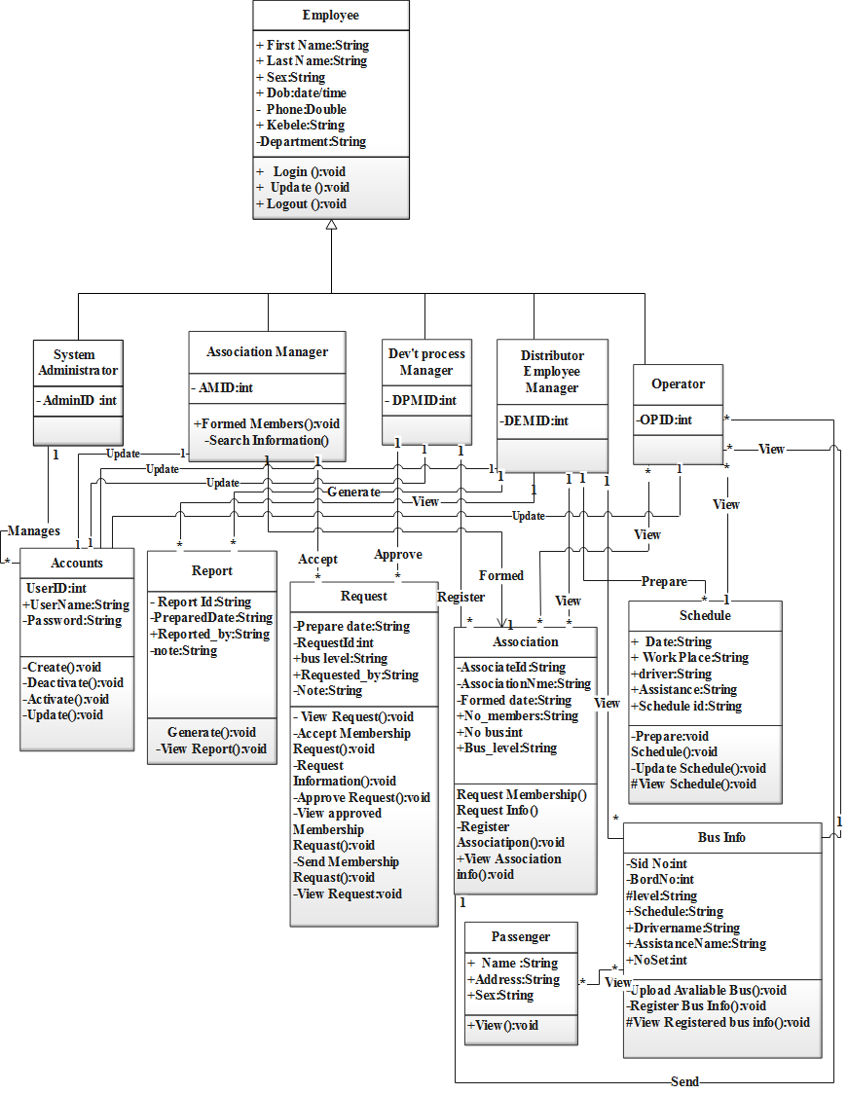
Figure 4.2 Class diagram

4.4 State chart modeling
State chart diagram is used to model dynamic nature of a system. They define different states of an object during its lifetime. And these states are changed by events. Reactive systems can be defined as a system that responds to external or internal events. State chart diagram describes the flow of control from one state to another state. States are defined as a condition in which an object exists and it changes when some event is triggered. So the most important purpose of state chart diagram is to model life time of an object from creation to termination. States represent situations during the life of an object. A solid arrow represents the path between different states of an object. Label the transition with the event that triggered it and the action that results from it. A filled circle followed by an arrow represents the object’s initial state. An arrow pointing to a filled circle nested inside another circle represents the object's final state.
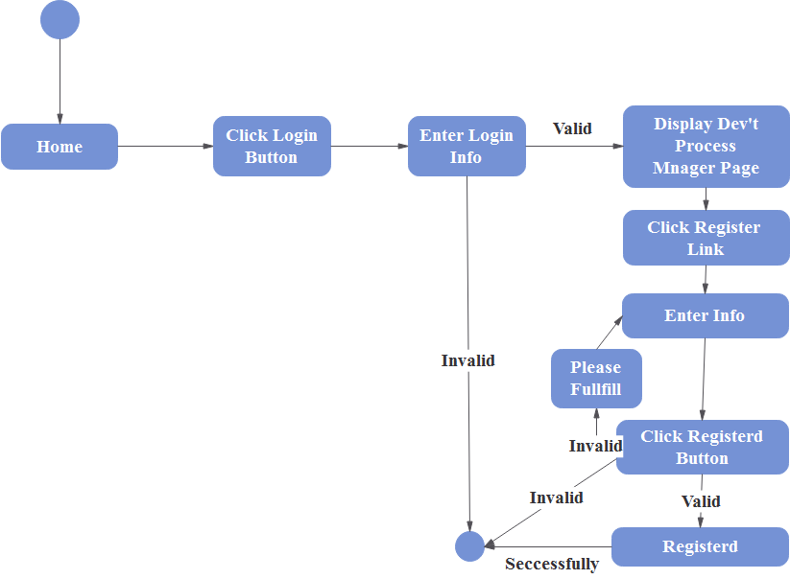
Figure 4.3 State chart modeling for register association
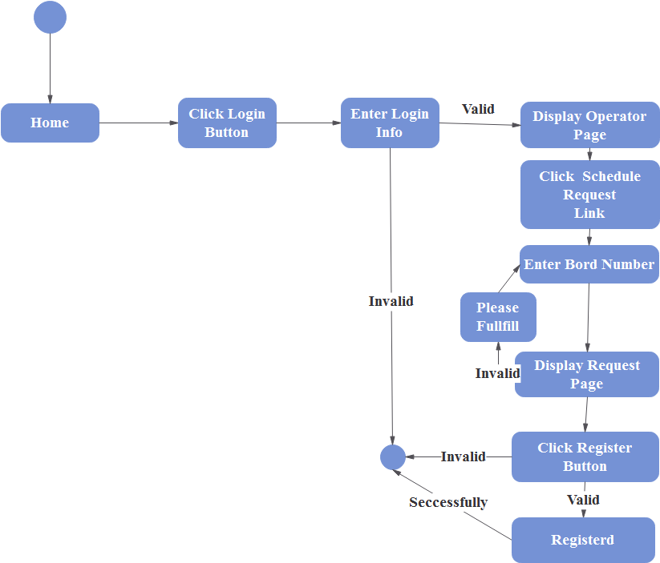
Figure 4.4 State chart modeling for schedule request

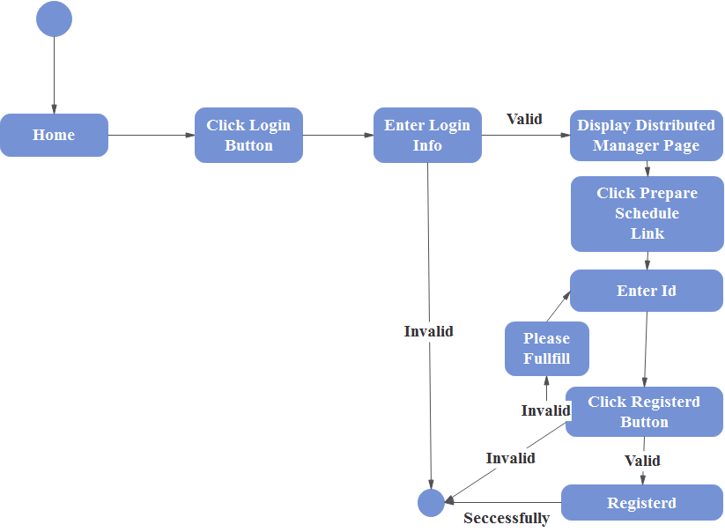
Figure 4.5 State chart modeling for prepare schedule

4.5 Collaboration Modeling
A collaboration diagram describes interactions among objects in terms of sequenced messages. It represents a combination of information taken from class, sequence, and use case diagrams describing both the static structure and dynamic behavior of a system.
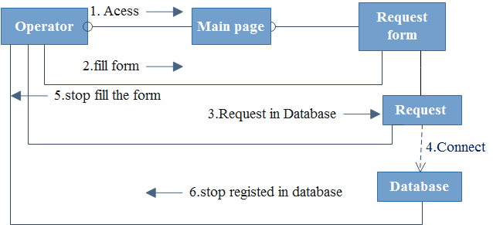
Figure 4.6 Collaboration Modeling For Schedule Request

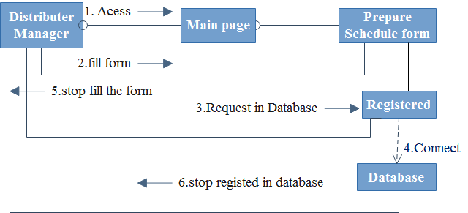
Figure 4.7 Collaboration modeling for prepare schedule

4.6 Component Modeling
By this Diagram, components of the system wired showing that there is relation among components; management of the system, owners, database and operations performed on databases such security issue.

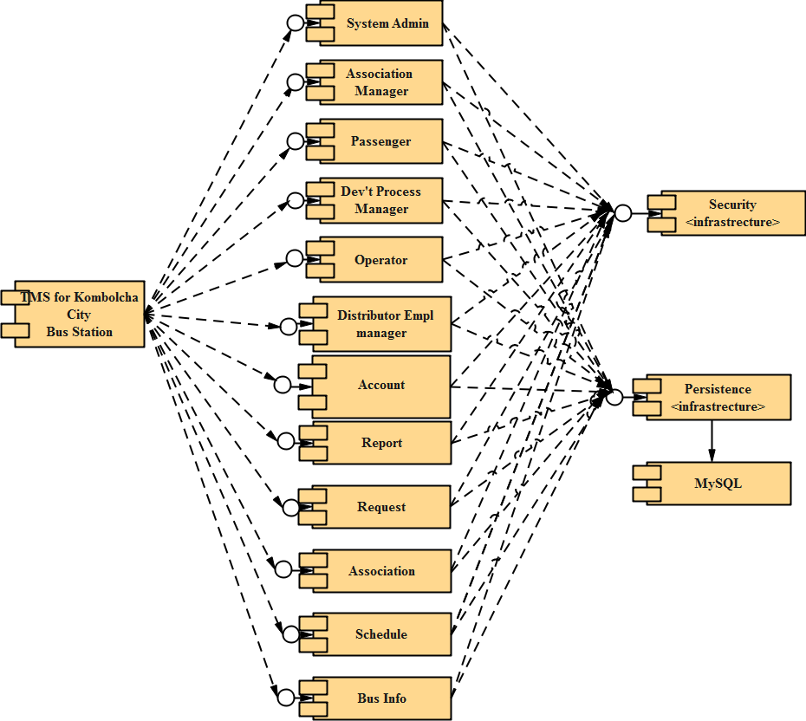
Figure 4.8 Component diagram

4.7 Deployment Diagram
The Deployment Diagram also helps to model the physical aspect of an Object-Oriented software system. It models the run-time configuration in a static view and visualizes the distribution of components in an application. In most cases, it involves modeling the hardware configurations together with the software components that lived on. Deployment diagram of our system shown blow.

Figure 4.9 Deployment diagram

4.8 Persistent Modeling
Persistence models are used to design the schema of your database. You typically need to draw a Persistence model whenever you are using a relational database to store your objects in. The strength of Persistence models is that data entities are conceptually the same as the tables of a relational database and that attributes are the same as table columns.

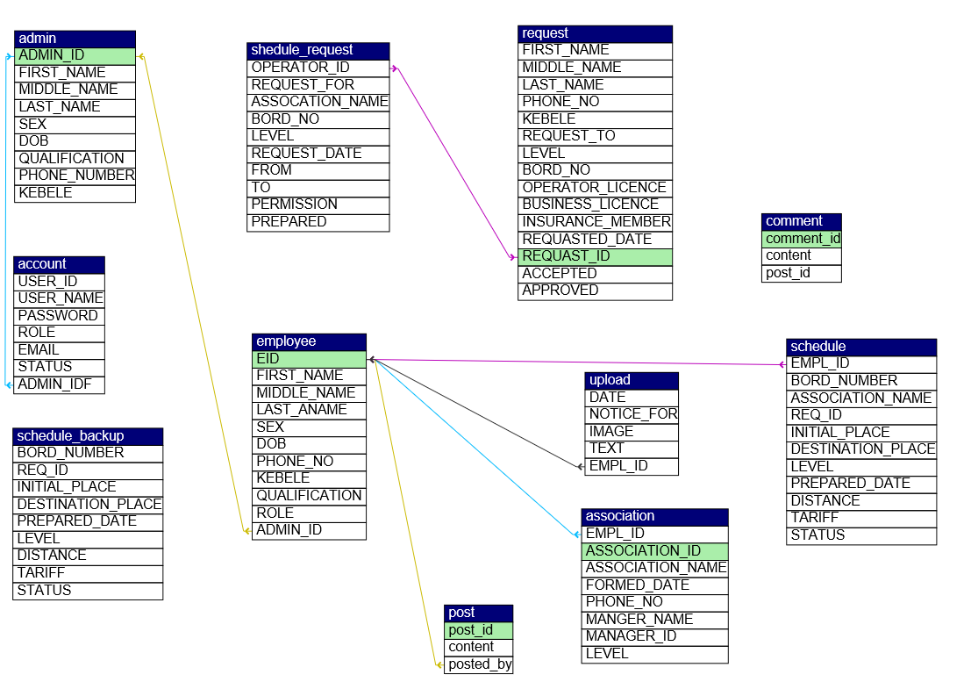
Figure 4.10 Persistent Diagram

4.9 User Interface
The design of user interfaces for this system for the purpose of designing how the interface seems like with the focus on maximizing the user experience. The goal of user interface design is to make the user's interaction as simple and efficient as possible, in terms of accomplishing user goals what is often called user centered design.
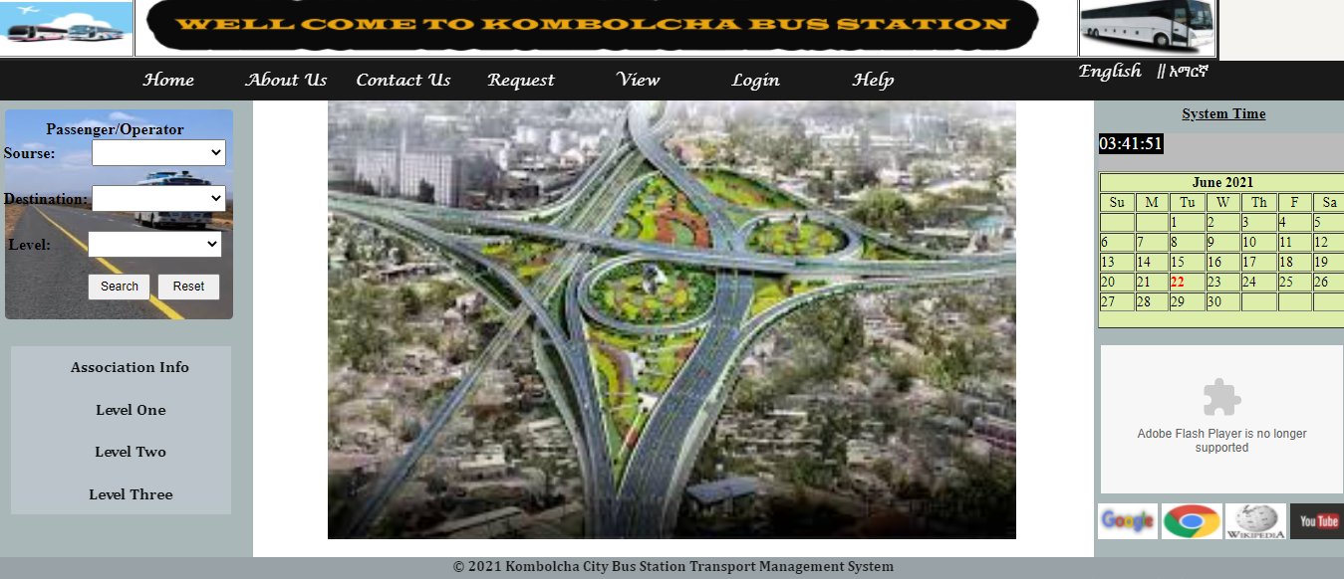
Figure 4.11 Homepage user interface

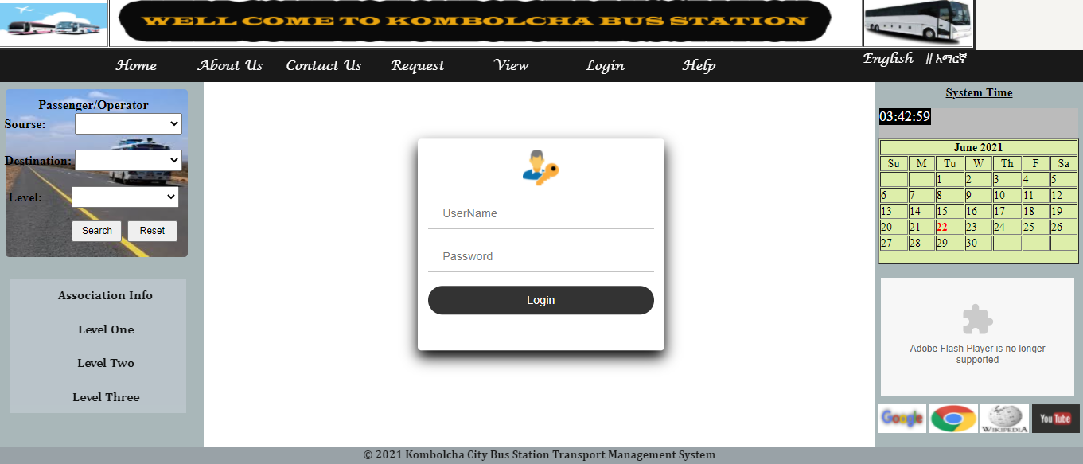
Figure 4.12 Login User Interface
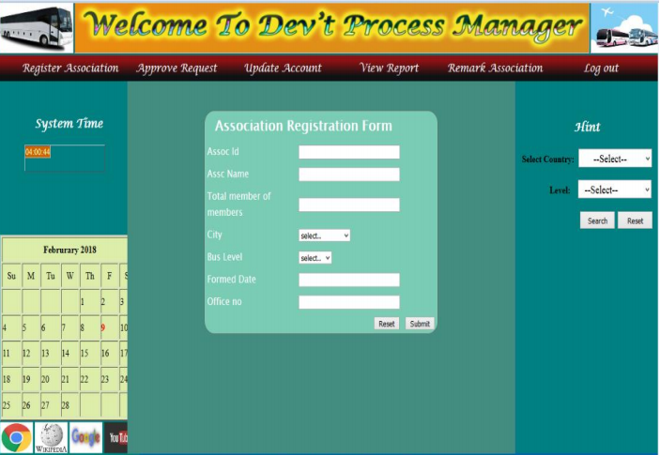

Figure 4.13 Association Registration user interface

Chapter Five

5. Coding, Implementation and Testing

5.1 Introduction
In this phase what the group members have done is turning the physical design specification into working computer code, and then the code is tested until most of the errors have been detected and corrected. User sites are prepared for new system and user must come totally on the new system rather than the existing one to get there work done. There are some managerial activities in this, coding, testing, and installation.

Coding
Sample code for login
<?php
session_start();
include 'connection/connection.php';
if (isset($_POST['login'])) {
$username = $_POST['uname'];
$password = $_POST['upassword'];
$pass = base64_encode($password);
$query = mysqli_query($con,"SELECT *FROM Account where USER_NAME='$username' and PASSWORD='$password'");
if (!$query) {
echo mysql_error();
}
if (mysqli_num_rows($query) > 0) {
$activate = mysqli_query($con,"select *from Account where USER_NAME='$username' and STATUS='0'");
if (mysqli_num_rows($activate) > 0) {
$result = mysqli_query($con,"SELECT * FROM Account WHERE USER_NAME='$username' and PASSWORD='$password'");
if (mysqli_num_rows($result) > 0) {
while ($row = mysqli_fetch_assoc($result)) {
$_SESSION['USER_NAME'] = $username;
$_SESSION['ROLE'] = $row['ROLE'];
$_SESSION['USER_ID'] = $row['USER_ID'];
$_SESSION['last_time'] = time();
if ($row['ROLE'] == 'sysadmin') {

echo "<script>window.location='Admin/Adminpage.php';</script>";
}
else if
($row['ROLE'] == 'assomanager') {
header("Location:AssoManagerPage/AssociationManpage.php");
}
else if ($row['ROLE'] == 'devmanager') {
header("Location:DevtProcessManPage/dev't process manager.php");
}
else if ($row['ROLE'] == 'Employee') {
header("Location:DisterEmployee/Employeepage.php");
}
else if ($row['ROLE'] == 'distermanager') {
header("Location:DistributerManagerPage/DistributerManPage.php");
}
else if ($row['ROLE'] == 'operator') {
header("Location:OperatorPage/Operatorpage.php");
}
else if ($row['ROLE'] == 'Passenger') {
header("Location:PassengerPage/UserPage.php");
}

}
}
else {
echo '<script type="text/javascript">alert("You are entered incorrect password!");window:location=\'index.php\';</script>';
}
}
else {
echo '<script type="text/javascript"> alert("Sorry Your Account is Deactivated Contact With Adminstrator!");window:location=\'index.php\';</script>';
}
}
else {
echo '<script type="text/javascript"> alert("user name not exist!");window:location=\'index.php\';</script>';
}
}
mysqli_close($con);
?>

5.2 Final Testing of The system
Black box testing: -To test our system, the tester may use black box testing, if he/she has not enough time to check internal modules or codes. By looking only input /output or user interface, the tester can test our systems functionalities without looking the internal code. We used this testing technique for the following reasons:-
- This testing type is more effective on larger units of code
- Tester needs no knowledge of implementation, including specific programming languages
- Tester and programmer are independent of each other
- Tests are done from a user's point of view
White box testing: -
In this type of testing, skilled man in different programming languages tries to test the logic of our system. If the person who tests the system is not skilled, it is difficult to understand our systems functionality. If any failures occur while testing the system in all of the above testing methods, the team will take immediate correction where this fault occurred before jumping to next work. So, that it will meet the goal.

Table 5.1 Test case to register association
Test Case1: Register Association
Test case objective : To register Association
Test case description: Dev’t process manager enters basic info of the association, then presses register button. Client program contacts with server, server contacts with the database, and database checks for registration and sends message to the association.
Requirements Verified: Yes
Test Environment: Apache MySQL server must be in running state, Database Should contain appropriate table and link must be established between server and client program.
Test Setup/Pre-Conditions: Apache server should be in running state and all fields should be filled.
Actions |  | Expected Results
The Dev’t process manager should login and press the register menu. | Displays registration page.
Dev’t process manager should enter association information | Displays success message
If some fields are not filled the system display to fill the fields again.

Table 5.2 Test case to view schedule
Test Case 2: view schedule
Test case objective : To view schedule
Test case description: Operator enters license id, then presses check button. Client program contacts with server, server contacts with the database, and database checks for license id and display .
Requirements Verified: Yes
Test Environment: Apache mysql server must be in running state, Database Should contain appropriate table and link must be established between server and client program.
Test Setup/Pre-Conditions: Apache server should be in running state and all fields should be filled.
Actions |  | Expected Results
The operator should login and press the view license menu. | Display.
Operator should enter license id | Displays Schedule
If no schedule display not found in database

Table 5.3 Test case to update account
Test Case 3:update account
Test case objective : To update account
Test case description: Any system user’s presses update button. Client program contacts with server, server contacts with the database, and database retrieve data and display data to the user
Requirements Verified: Yes
Test Environment: Apache Mysql server must be in running state, Database Should contain appropriate info and link must be established between server and client program.
Test Setup/Pre-Conditions: Apache server should be in running state and all fields should be filled.
Actions |  | Expected Results
The system user’s should login and press the update account link. | Displays page.

5.3 Hardware software acquisitions
For the project implementation; the following Software and hardware tools are used.
Hardware Tools:-
- Server: for connection to the client computer(to host the system)
- Computers
- Network connection
- Printer: For printing Documentation
Software Tools
For the System implementation the following software’s are used.
      - Dream weaver CS5.5
      - Notepad++
      - Mysql database server
      - WAMP server

5.4 User manual preparation
No more manual preparation is needed for users, because the system developed is not software and it is not installed on a client computer. After the implementation has been completed, it is directly hosted on Network (server).

5.5 Training
During the deployment of the system, the project group members will give short time training for the system administrators and workers explaining how the system works and in what way they can manage the system developed.

5.6 Installation Process
Since the project is a web based System, there is no need to install it on a particular machine rather it will be hosted on a server.
5.7 Start-up strategy
Once the system has been published, the user can start and access his/her authorized page by entering the correct Username and Password with proper authentication and authorization processes.

Chapter Six

6. Conclusions and Recommendations

6.1. Conclusion
As the scope of this project describes we developed Transport management system for Kombolcha bus station to make it reliable. The system will register bus and association, manage license, prepare schedule and perform additional task that will be performed by the system.
So the system will:
- Minimize the work load
- Minimize the time required to perform task
- Reduce the number of employee involved
This document use the object oriented technology called UML (unified modeling language) that enable the user to understand the software easily .We finally conclude that Bus station will be benefited from the system developed.

6.2. Recommendation
The system we have developed is Web based system it needs a skilled person to work with the system. So, we recommend the system should be entitled to the responsible and skilled person. We highly recommend the system should be kept in highly safe and favorable condition.
Our recommendation towards the project modification of some modules and adding the other parts (functions) like security issue for notify client , tariff formation and communication with other bus station.

References
- Object-Oriented Software Engineering using UML, Patterns, and Java Third Edition by Bernd Bruegge and Allen H. Dutoit.
- HTTP:// www.historical development of transport Ethiopian economy.
- Background and biography of Kombolcha city, www.google.com April 3, 2021
- Faculty of Informatics (2013), project template, KIOT.
- group 5(2013), fundamentals of software engineering group assignment proposal, KIOT in Wollo University.
- https://transportgeography.org/contents/chapter1/what-is-transport-geography/transport-system-overview/
- http://www.w3school.com
- http://en.wikipedia.org/wiki/Sequence_diagram
- http://en.wikipedia.org/wiki/Class_diagram

Appendices
We are final year students of the faculty of Informatics in KIOT. We are doing/developing an industrial project on the transport management of the Kombolcha bus Station to automate it into a computerized system. Therefore, we need your positive attitude towards giving us the general working of the bus station for not more than 30 minutes.
Interview Questions
- What are the basic tasks that are performed at the bus station?
- What are the different actors present in the bus station?
- How do you arrange buses in the bus station?
- How do you adjust turns/ assign schedules for the vehicles?
- How often do you adjust the schedule of a vehicle for a month?
- Can you tell us something about tariff formulation and assignment?
- Is there any computerized system developed for the bus station before?
- Do you think the computerized system will be helpful for you?

